Coursera Stanford Machine Learning Notes

Vid 1 - Welcome

* Use lots of ML today, w/out using it.
* Search engines, Facebook tagging, spam filter, etc.
* Many AI aims to use algos to learn how the brain learns in order to know the algos.
* Need to get the stuff to work on stuff you care about.
* Prevelant today because it grew out of AI and new capability for computers.
* Didn’t know how to do stuff like email spam, so had to get a machine to learn it by itself.
* Andrew Ng gets contacted by a ton of people, ton of fields, that ML has an impact on.
* Examples
  + Database mining thanks to large data sets and web click data. Medical records, biology, engineering.
  + Applications that can’t be taught/coded by hand, so helicopters, handwriting recognition, most of NLP (wait what?), comp vision
    - I guess stuff like the Punkt Sentence tokenizer but meh
  + Recommendations from Amazon, Netflix, etc.
  + Used to understand human learning

Vid 2 – What is ML?

* No really good definition.
* Arthur Samuel 1959 – ML is field of study that gives computers ability to learn without being exactly programmed.
  + Checkers thing, he wasn’t good, but computer played against it himself
* Tom Mitchell 1998 – Well posed learning problem: a computer program is said to learn from experience E with respect to some Task T and some performance measure P, if its performance on T, as measured by P, improves experience E.
  + T is playing checkers
  + P is probablility of winning against new opponent.
  + E is experience of playing 10s of thousands of games against itself
* Classifiying email is T, watching me label it is E, fraction of correct one is P.
* ML Algos
  + Supervised learning – you teach computer something
  + Unsupervised learning – computer teaches itself
  + Two main ones.
* Others
  + Reinforcement learning, recommender systems
* Also: practical advice for applying learning algos. Andrew Ng covers a lot of it.
  + Should learn how to use the tools properly
  + That way, you don’t waste your time on something that won’t work for six months.
* Wants to make me one of the best people on ML. What a nice guy ☺

Review from them: What is Machine Learning?

Two definitions of Machine Learning are offered. Arthur Samuel described it as: "the field of study that gives computers the ability to learn without being explicitly programmed." This is an older, informal definition.

Tom Mitchell provides a more modern definition: "A computer program is said to learn from experience E with respect to some class of tasks T and performance measure P, if its performance at tasks in T, as measured by P, improves with experience E."

Example: playing checkers.

E = the experience of playing many games of checkers

T = the task of playing checkers.

P = the probability that the program will win the next game.

In general, any machine learning problem can be assigned to one of two broad classifications:

Supervised learning and Unsupervised learning.

Use the user discussion forums.

Vid 2 – Intro to Supervised Learning

* Most common type of machine learning problem.
* Start with example – want to predict housing prices.
  + Friend has a house that’s 750 sq ft and wants to know how much to sell it
  + A ML algo can fit a straight line through data, seems like house can be sold for 150,000 dollars.
  + Can also try to fit a quadratic or a second-order polynomial, seems like you can sell it for $200k.
  + Later we’ll choose to see what’ll be more accurate, the quadratic or the linear one, no fair picking the one that gives you more money ☺
  + Each is good example of supervised learning Algo
* Supervised learining – gave the algo a data set where the “right answers” were given.
  + For every example, gave it the right price the houses were sold for.
* This is a regression problem – predict continuous valued output (like price).
  + Regression terms for continuous value attribute
* Another example – see if breast cancer is malignant or benign.
  + Malignant is dangerous, benign is harmless.
  + Horizontal axis is size of tumor, vertical is 1 or 0. 1 is malignant, 0 is benign.
  + Example is below. Say we have a friend who’s value is inbetween first malign and third benign tumor. Is it malignant?
  + 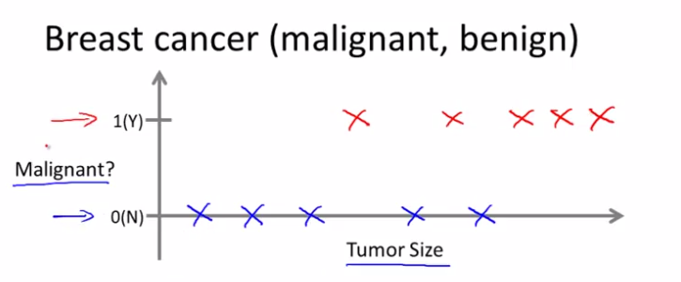This is a classification problem. A discrete value is outputted. Don’t need to be 2 values, values can be 0, 1, 2, 3. 0 could be benign, 1 can be type 1 cancer, 2 can be type 2 cancer, etc, still a classification problem.
  + Can use different symbols for same data.

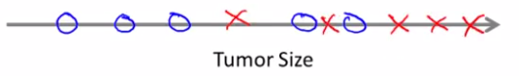

* + O’s are benign, x’s are dangerous. Only use tumor size in this example.
  + Might have more th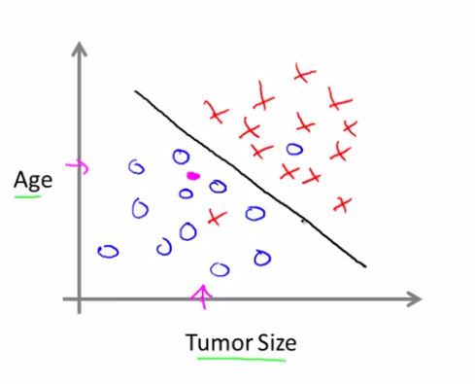an one attribute in other problems.
  + Friend’s tumor in pink, the ML algo puts the line through the sides and it’ll determine that friend’s tumor is probably benign.
    - Two features
  + Lots of features with this real problem – clump thickness, uniformity of cell size, uniformity of cell shape, etc.
* Can deal with an infinite number of features.
* How do you deal with this? There’s an algo called support vector machine that allows computer to deal with an infinite number of features.
* Supervised learning – told what’s the correct answer, regression problem predicts a continuous value, and classification problem picks where to put something. 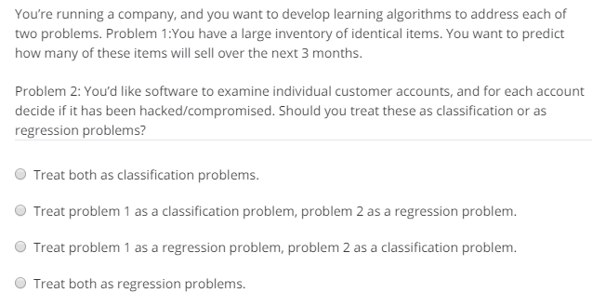
* I’m saying the third option. Correct!
* For first statement, keep that as a continuous value, and second is classification so we can set value we want to denote is 0 – not hacked, and 1 – hacked.

Supervised Learning

In supervised learning, we are given a data set and already know what our correct output should look like, having the idea that there is a relationship between the input and the output.

Supervised learning problems are categorized into "regression" and "classification" problems. In a regression problem, we are trying to predict results within a continuous output, meaning that we are trying to map input variables to some continuous function. In a classification problem, we are instead trying to predict results in a discrete output. In other words, we are trying to map input variables into discrete categories.

Example 1:

Given data about the size of houses on the real estate market, try to predict their price. Price as a function of size is a continuous output, so this is a regression problem.

We could turn this example into a classification problem by instead making our output about whether the house "sells for more or less than the asking price." Here we are classifying the houses based on price into two discrete categories.

Example 2:

(a) Regression - Given a picture of a person, we have to predict their age on the basis of the given picture

(b) Classification - Given a patient with a tumor, we have to predict whether the tumor is malignant or benign.

Vid 3 – Unsupervised Learning

* Supervised learning, get data sets that look like the example, it has x’s and o’s and you know what’s good and what’s bad and on which axis’s. What’s benign, malignant.
* Unsupervised learning – no labels, same labels, not told what to do with it, here is a data set. Can you find some structure in the data?

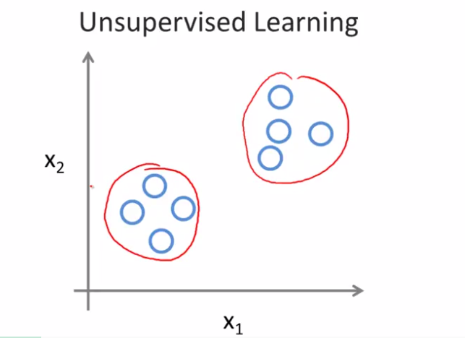

* Unsupervised learning would realize this data is in two different clusters, so it’s a clustering algorithm.
* Example: google news. Puts 10s of thousands of news stories on the webs and cohesively puts them together. BP oil spill, different sources.
* Clustering used for a lot of things – used for genomics.
  + Can show how popular a specific gene is.
  + Unsupervised learning because not saying who’s type 1, type 2, etc.
  + Find structure in data for me pl0x
* Used to organize large computer clusters and find which machines tend to work together. If you put them together, then it works faster
* Social network analysis – groups of people who identify together
* Market segmentation – let algo discover based on data who’s in what
* Used for astronomical data analysis (WOW) on info on how galaxies are formed
* Cocktail party problem
  + All overlapping voices, hard to hear who’s in front of you.
  + 2 people talk at same time, put two mics in the room.
  + b/c they’re at 2 different distances from speakers, forms a combo of it. Speaker 1 is closer to mic 1, speaker two is closer to mic 2, each records an overlap of the voice.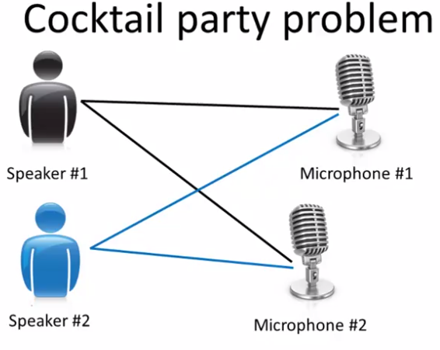
* can take two audio recordings and say it’s being added together using the cocktail party algorithm, and can separate them! Separates the Spanish-English counting to ten example.
  + Can separate songs and speech too.
* This algorithm is one line of code. Took a lot of work but they can be short programs.
* Using Octave for this class. (cocktail party is [W,s,v] = svd((repmat(sum(x.*x,1),size(x,1),1).*x)*x’);)
* Will be implementing algos in octave (or MATLAB)
* Silicon Valley uses Octave to test stuff. Svd is a linear algebra thing (as you know!)
* Learn faster using octave as your programming environment.
* Use a tool like octave to test ml algo, then in java or c++

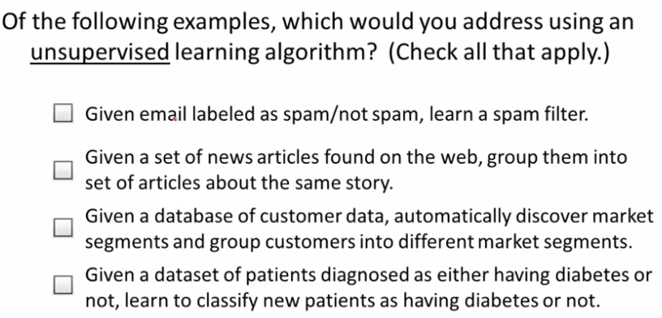

* I think it’s the middle two. Correct!
* Unsupervised Learning
* Unsupervised learning allows us to approach problems with little or no idea what our results should look like. We can derive structure from data where we don't necessarily know the effect of the variables.
* We can derive this structure by clustering the data based on relationships among the variables in the data.
* With unsupervised learning there is no feedback based on the prediction results.
* **Example:**
* Clustering: Take a collection of 1,000,000 different genes, and find a way to automatically group these genes into groups that are somehow similar or related by different variables, such as lifespan, location, roles, and so on.
* Non-clustering: The "Cocktail Party Algorithm", allows you to find structure in a chaotic environment. (i.e. identifying individual voices and music from a mesh of sounds at a [cocktail party](https://en.wikipedia.org/wiki/Cocktail_party_effect)).

Vid 4 - Model Representation – linear regression with one variable

* Linear Regression model
  + Model, and how it’s used for supervised learning.
* Using the Oregon housing prices example.
* Plotting it, friend has size 1250 sq ft.
* Can fit a straight line to the data and based on that, can maybe sell house for 220K.
* Supervised learning since we’re given the “right example” for each example in data.
* It’s a regression problem – predict real-valued output.
  + Other common type is classification problem where you get discrete valued output.
* More formally, in supervised learning, have data set. That’s a training set.
  + In this example, we have housing prices.
* Notation
  + m = number of training examples
  + x’s = input variable/features
  + y = output variable / target variable
  + (x,y) – single training example (a single row in a table)
  + (x(i), y(i)) – ith training example.
* so for Portland housing, x is size in feet squared, and price is y. m = 47 since there are 47 houses.
* x^1 = 2104, y^1 = 460
* The MC that came up was so trivial I didn’t bother snipping it.
* How a supervised algo works
  + Start with training set
  + Feed that into learning algorithm
  + Output a function, denoted as *h*, referred to as hypothesis.
  + Size of house (x) -> h -> estimated price (estimated value of y)
  + h maps from x’s to y’s.
* Why is it called hypothesis?
  + Used in early days of ML, and it stuck. Not like a science hypothesis.
* How do we represent hypothesis?
  + h_theta(x) = theta_0 + theta_1 x
  + shorthand: h(x)
  + this means: y is a linear function of x.
* sometimes we want to do non-linear stuff, but this is the building block for more complex stuff.
* This model is called the linear regression with one variable, with that being x.
* 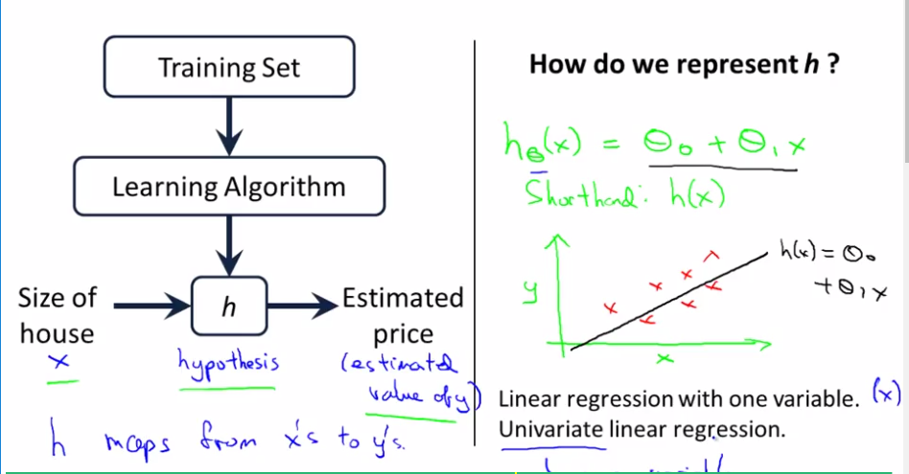AKA *Univariate linear regression*.

Model Representation

To establish notation for future use, we’ll use *x*(*i*) to denote the “input” variables (living area in this example), also called input features, and *y*(*i*) to denote the “output” or target variable that we are trying to predict (price). A pair (*x*(*i*),*y*(*i*)) is called a training example, and the dataset that we’ll be using to learn—a list of m training examples (*x*(*i*),*y*(*i*));*i*=1,...,*m*—is called a training set. Note that the superscript “(i)” in the notation is simply an index into the training set, and has nothing to do with exponentiation. We will also use X to denote the space of input values, and Y to denote the space of output values. In this example, X = Y = ℝ.

To describe the supervised learning problem slightly more formally, our goal is, given a training set, to learn a function h : X → Y so that h(x) is a “good” predictor for the corresponding value of y. For historical reasons, this function h is called a hypothesis. Seen pictorially, the process is therefore like this:



When the target variable that we’re trying to predict is continuous, such as in our housing example, we call the learning problem a regression problem. When y can take on only a small number of discrete values (such as if, given the living area, we wanted to predict if a dwelling is a house or an apartment, say), we call it a classification problem.

Vid 5 - Cost Function – LR w/ one var

* How to get the best fit for our data.
* Same training set as last time, with h_theta(x) = theta_0 + theta_1 x w/ m = 47.
* Theta’s are paramaters of the model.
* How to choose theta_i’s?
* With different choices, we get different hypothesis.

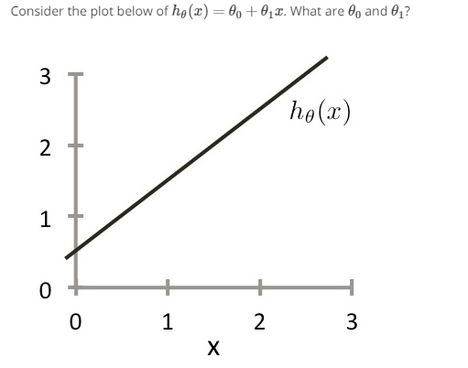

* I’m picking: theta_0 = 1.0, theta_1 = 0.5. lol never mind had it reversed, theta_0 = 0.5, theta_1 = 1.0.
* In linear regression, want to get straight line that captures the data, fits it well. How do we come up with theta_0, theta_1?
* Idea: choose theta_0, 1 so that h_0(x) is close to y for our training examples (x,y)
* Given x’s in training set, let’s pick accurate y values.
* Solve a minimization problem. Minimize theta_0 and theta_1. Want (h_0(x) – y) to be small, so (h_0(x) – y)^2 should be minimized.
* (x^y, y^i).
* 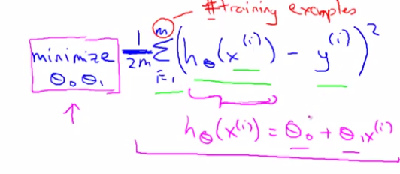Overall objective function. Want to minimize theta_0 and theta_1 by minimizing the 1/2m (average) of from 1 to m of the function’s output – the actual output squared.
* Formalize: $J\left(θ_{0}, θ_{1}\right)=\frac{1}{2m}\sum_{i=1}^{m}{{\left(h_{θ \left(x^{i}\right)}- y^{i}\right)}^{2}}$
* 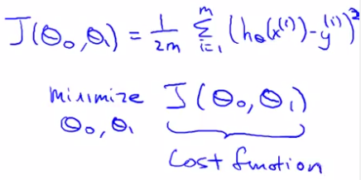This cost function is called the *squared error function* or squared error function.
* Why do we take squares of error? Because it works wells for regression problems.
* This is the most commonly used ones for regression problems.
* This is just a math representation. Next couple vids he’s going to talk about what the function is doing, and why we wanna use it.

Cost Function

We can measure the accuracy of our hypothesis function by using a cost function. This takes an average difference (actually a fancier version of an average) of all the results of the hypothesis with inputs from x's and the actual output y's.

J(θ0,θ1)=12m∑i=1m(y^i−yi)2=12m∑i=1m(hθ(xi)−yi)2

To break it apart, it is 12 x¯ where x¯ is the mean of the squares of hθ(xi)−yi , or the difference between the predicted value and the actual value.

This function is otherwise called the "Squared error function", or "Mean squared error". The mean is halved (12) as a convenience for the computation of the gradient descent, as the derivative term of the square function will cancel out the 12 term. The following image summarizes what the cost function does:



* It’s squared to cancel out the derivative, and halved for convenience of computing gradient.

Vid 6 – Cost function: Intuition 1

* 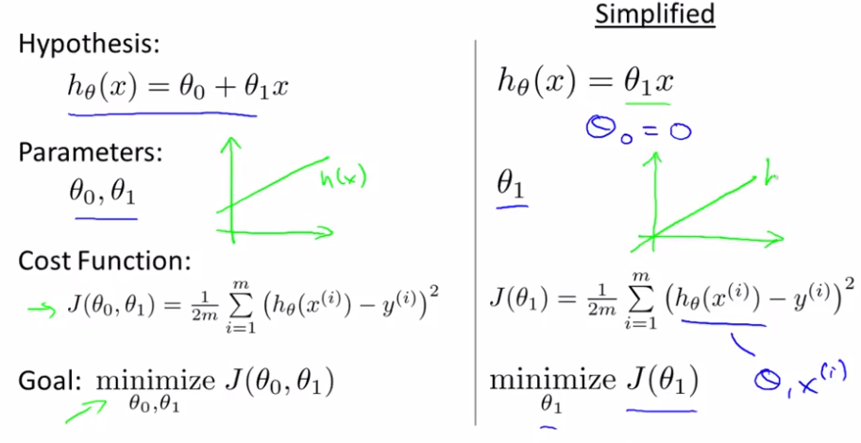h_theta(x) is for fixed theta_1, this is a function of x.
* J(theta_1), function is a parameter of theta_1.
* What is J(theta1) when it equals one?
* 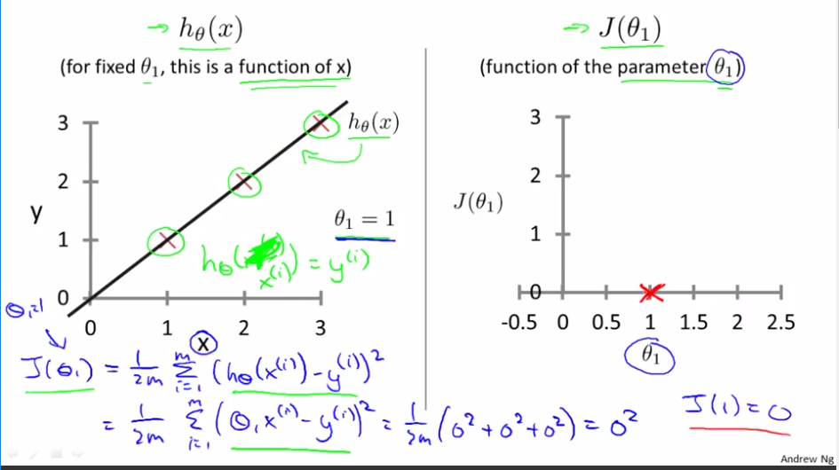if theta_1 = 0.5, compute J(0.5). that is 1/2m of cost function, it’s the sum of square values of height of data point – the actual point squared. So when theta_1 = 0.5, J(0.5) = 1/2m[(0.5 – 1)^2 + (1-2)^2 + (1.5-3)^2] where m = 3
* Can have negative values of theta_1 as well.
* Optimization objective of learning algo is to get the theta_1 that minimizes J(theta_1). The minimum one for this is theta_1 = 1 since you get the best fit and it’s the smallest value for it.
* Want to minimize J(theta_1)

Cost Function - Intuition I

If we try to think of it in visual terms, our training data set is scattered on the x-y plane. We are trying to make a straight line (defined by *hθ*(*x*)) which passes through these scattered data points.

Our objective is to get the best possible line. The best possible line will be such so that the average squared vertical distances of the scattered points from the line will be the least. Ideally, the line should pass through all the points of our training data set. In such a case, the value of *J*(*θ*0,*θ*1) will be 0. The following example shows the ideal situation where we have a cost function of 0.



When *θ*1=1, we get a slope of 1 which goes through every single data point in our model. Conversely, when *θ*1=0.5, we see the vertical distance from our fit to the data points increase.



This increases our cost function to 0.58. Plotting several other points yields to the following graph:



Thus as a goal, we should try to minimize the cost function. In this case, *θ*1=1 is our global minimum.

Vid 7 – Cost Function: Intuition II

* This vid is about contour plots
* Don’t need to understand it so well, okay to skip this lec
* Can only draw arcs as a function of theta_1.
* With two thetas, the cost function might be a 3-D surface plit, where the axes are labeled theta_0 and theta_1.
* 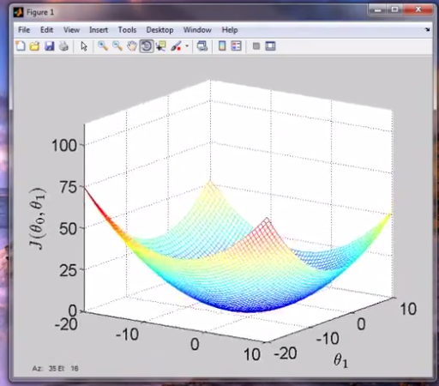Height of surface of point is the value of J(theta_0, theta_1)
* It’s a bowl shape!
* Ain’t going to use these 3d surfaces for shape, instead will use contour plots and contour figures. Ring of values are same data for same value for J(theta_0, theta_1).
* Imagine a bowl shaped function where the middle is the smallest point.
* What we want is a value of theta_0 and theta_1 is to find the minimum value of J.

# Cost Function - Intuition II

A contour plot is a graph that contains many contour lines. A contour line of a two variable function has a constant value at all points of the same line. An example of such a graph is the one to the right below.



Taking any color and going along the 'circle', one would expect to get the same value of the cost function. For example, the three green points found on the green line above have the same value for *J*(*θ*0,*θ*1) and as a result, they are found along the same line. The circled x displays the value of the cost function for the graph on the left when *θ*0 = 800 and *θ*1= -0.15. Taking another h(x) and plotting its contour plot, one gets the following graphs:



When *θ*0 = 360 and *θ*1 = 0, the value of *J*(*θ*0,*θ*1) in the contour plot gets closer to the center thus reducing the cost function error. Now giving our hypothesis function a slightly positive slope results in a better fit of the data.



The graph above minimizes the cost function as much as possible and consequently, the result of *θ*1 and *θ*0 tend to be around 0.12 and 250 respectively. Plotting those values on our graph to the right seems to put our point in the center of the inner most 'circle'.

* Want to get closer to the center, and having a positive slope. This results in a better fit of the data.

Vid 8 – Gradient Descent

* Algorithm used to calculate the minimize the cost.
* Used in a lot of algorithms.
* Have some function J(theta_0, theta_1), want its minimum
* Outline – start with some theta_0, theta_1, keep changing to reduce J(theta_0, theta_1) until we get a minimum.
  + Can be applied up to some theta_n
* Start w/ some initial getters for theta_0, theta_1. Initialize them to zero. Will keep changing them a little bit to try and reduce them in order to get to a minimum.
  + Can initialize to other things than zero zero too.
* 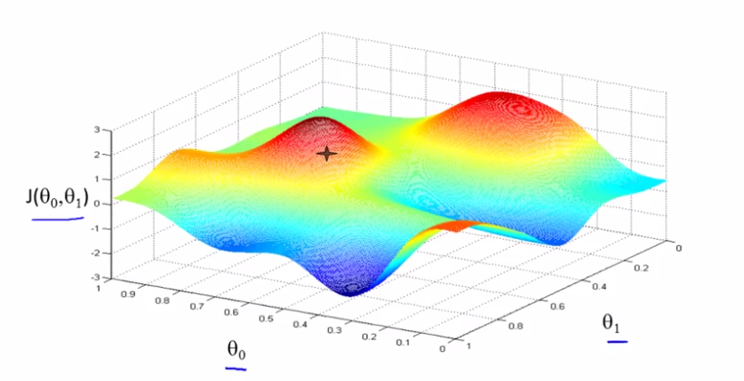Going to spin this 360 degrees when starting from that point on the red hill. Ask myself, if I want to go down the hill as quickly as possible, which direction would I step in?
* A little down from the star is the best direction. You’re on the new point, which direction should I take to go downhill? Keep going until you converge to the local minimum.
* Interesting property: imagine if you started it a little to the right of the point above. You’d go towards 0.4, to a different local optimum on the right.
* Here’s the definition of the gradient decesent agorithms, will do theta_j until convergence:
* := is assignment.
  + a := b means set a equal to value of b. a = b is truth assortment. Making a claim that a = b.
  + The alpha is a variable called the learning rate. The bigger it is, the greater of a step we take down the hill. The lower it is, the smaller of a step we take down the hill.
  + Then there’s the derivative term in blue.
  + Need to update theta_0 and theta_1. For the whole equation, want to simultaneously update theta_0 and theta_1.
  + First compute the RHS for theta_0 and theta_1, and at the same time, update theta_0 and theta_1. Don’t want to update one at a time b/c screwing with values.
  + People always mean simultaneous update when talking about gradient descent.
* 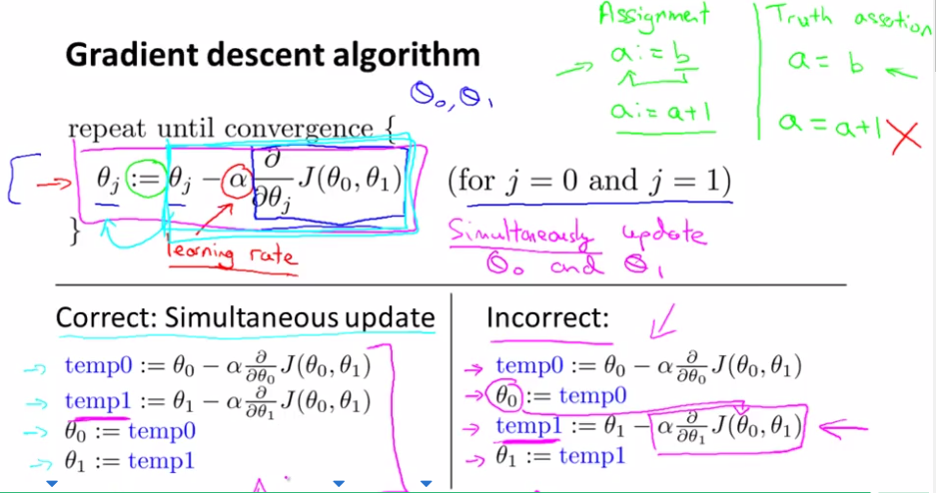next video is about the derivative / partial derivative stuff he didn’t cover now. I mean you know how to do it, it’s just partials.

# Gradient Descent

So we have our hypothesis function and we have a way of measuring how well it fits into the data. Now we need to estimate the parameters in the hypothesis function. That's where gradient descent comes in.

Imagine that we graph our hypothesis function based on its fields *θ*0 and *θ*1 (actually we are graphing the cost function as a function of the parameter estimates). We are not graphing x and y itself, but the parameter range of our hypothesis function and the cost resulting from selecting a particular set of parameters.

We put *θ*0 on the x axis and *θ*1 on the y axis, with the cost function on the vertical z axis. The points on our graph will be the result of the cost function using our hypothesis with those specific theta parameters. The graph below depicts such a setup.



We will know that we have succeeded when our cost function is at the very bottom of the pits in our graph, i.e. when its value is the minimum. The red arrows show the minimum points in the graph.

The way we do this is by taking the derivative (the tangential line to a function) of our cost function. The slope of the tangent is the derivative at that point and it will give us a direction to move towards. We make steps down the cost function in the direction with the steepest descent. The size of each step is determined by the parameter α, which is called the learning rate.

For example, the distance between each 'star' in the graph above represents a step determined by our parameter α. A smaller α would result in a smaller step and a larger α results in a larger step. The direction in which the step is taken is determined by the partial derivative of *J*(*θ*0,*θ*1). Depending on where one starts on the graph, one could end up at different points. The image above shows us two different starting points that end up in two different places.

The gradient descent algorithm is:

repeat until convergence:

*θj*:=*θj*−*α*∂∂*θjJ*(*θ*0,*θ*1)

where

j=0,1 represents the feature index number.

At each iteration j, one should simultaneously update the parameters *θ*1,*θ*2,...,*θn*. Updating a specific parameter prior to calculating another one on the *j*(*th*) iteration would yield to a wrong implementation.



* The direction of the step taken is determined by the derivative (direction the slope of the tangent line is going in) and the amount the step is taken by is a result of alpha.

Vid 9 – Gradient Descent Intuition

* Showing the algo again.
  + Alpha is the learning rate, how big a step do we take.
  + Then derivative term, this video is about these two terms.
* Want to minimize a cost function of just one parameter, theta_1, where theta_1 is in all real numbers.
* Theta_1 = theta_1 – alpha * derivative of J(theta_1). Would be partial of theta_1 but there’s only one variable.
* Now he’s explaining what a derivative is, slope of the tangent line.
* Line has a positive slope, so positive derivative.
* Theta_1 = theta_1 – alpha * positive number. Alpha is always positive.
  + Going to end up moving theta_1 to the left, which is good since it’ll get us to the minimum.
* 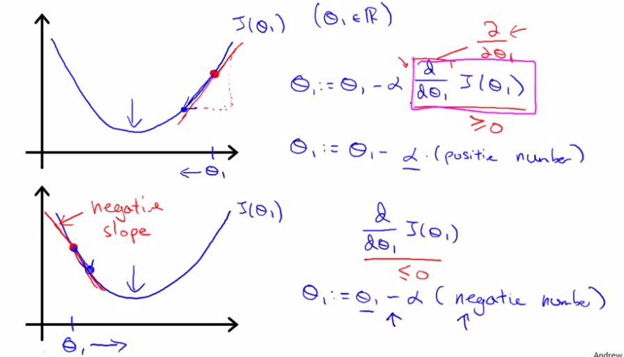Now what if the slop is negative? That means it has negative derivative, so it’ll be theta_1 – alpha(negative number) so theta_1 will increase.
* What if alpha is too small? Then gradient descent can be slow.
  + Would need a lot of steps.
* If alpha is too big, it can overshoot the minimum and fail to converge, even diverge.
  + You’ll go back and forth and up to the minimum.
* Tricky question: what if theta_1 is already at the local minimum? What will it do? This is a mid-video question.
  + My answer: originally it was decrease theta_1 because I thought it might by a small amount if it wasn’t exactly the minimum, but that wasn’t the question. It will actually just leave theta_1 unchanged, which is what I picked next.
* Gradient descent can converge to a local minimum, even when the learning rate is fixed.
* As we approach a local minimum, gradient descent will automatically take smaller steps. So, no need to decrease alpha over time.

# Gradient Descent Intuition

In this video we explored the scenario where we used one parameter *θ*1 and plotted its cost function to implement a gradient descent. Our formula for a single parameter was :

Repeat until convergence:

|  |
| --- |
| *θ*1:=*θ*1−*α d/dθ*1*J*(*θ*1) |

Regardless of the slope's sign for *ddθ*1*J*(*θ*1), *θ*1 eventually converges to its minimum value. The following graph shows that when the slope is negative, the value of *θ*1 increases and when it is positive, the value of *θ*1 decreases.



On a side note, we should adjust our parameter *α* to ensure that the gradient descent algorithm converges in a reasonable time. Failure to converge or too much time to obtain the minimum value imply that our step size is wrong.



### **How does gradient descent converge with a fixed step size *α*?**

The intuition behind the convergence is that *ddθ*1*J*(*θ*1) approaches 0 as we approach the bottom of our convex function. At the minimum, the derivative will always be 0 and thus we get:

|  |
| --- |
| *θ*1:=*θ*1−*α*∗0 |



Vid 10 – Gradient Descent for Linear Regression

* 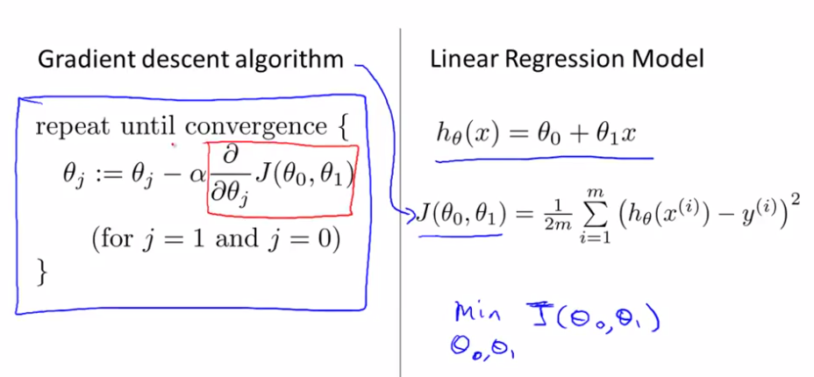Going to put together linear regression and cost function in order to get a straight line for our data.
* In order to write the gradient descent algorithm, need the derivative (stuff in red).
* Computing partial derivatives requires some MVC. I tried calculating them myself, got the one for theta_0, didn’t get the end x^(i) term in the second.
* 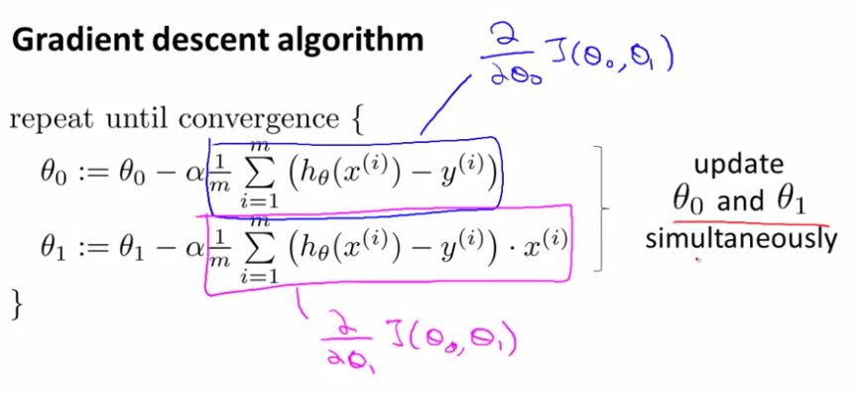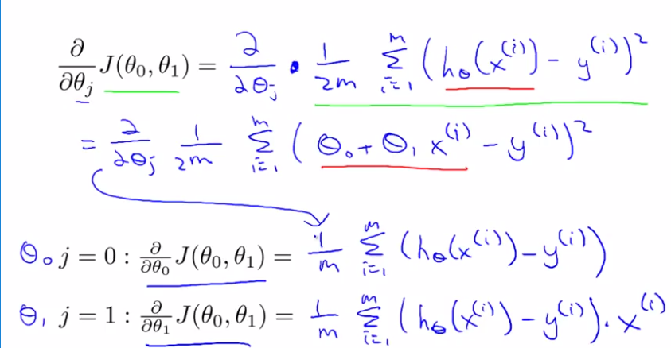can now plug them into our linear regression algorithms. Here they are, our gradient descent algorithm:
* Some problems w/ gradient descent – can be susceptible to local optima.
* Turns out cost function for gradient descent will always be the bowl shape, which is a convex function.
  + Informally, it’s a bowl-shaped function, doesn’t have any local optima except for the one global optima.
  + You always get this with a linear regression cost function.
* He then shows it in action, described below:

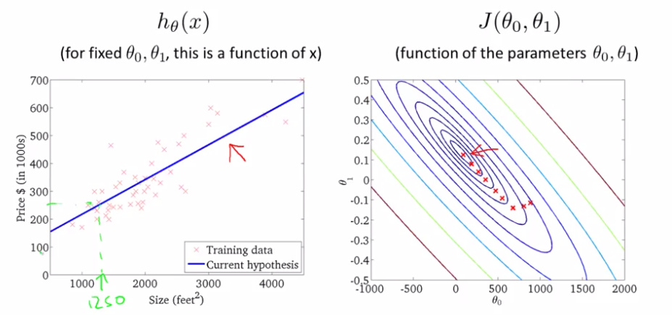

* This is what’s called “Batch” gradient descent.
  + Batch means – each step of gradient descent uses all the training examples.
  + Comes from how we’re taking a look at all the training examples, when we’re computing derivatives, we’re getting the sum of m training examples, so that’s where batch comes from.
* There are other version of gradient descent which aren’t batch, and don’t look at the entire training set.
* Question in vid – WOTF is true?
  + 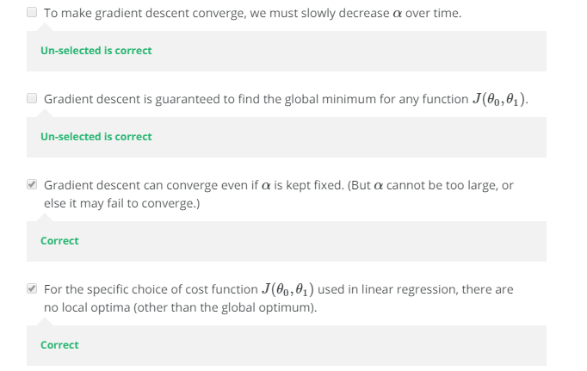Ima say:
* Yeah boiiiiiiii
* That’s linear regression with gradient descent.
* There exists a numerical solution to the cost function J without needing to use an iterative algorithm like gradient descent, which we’ll talk about later. It’s called the normal equations method.
  + Gradient descent will scale grater to larger training sets.
* 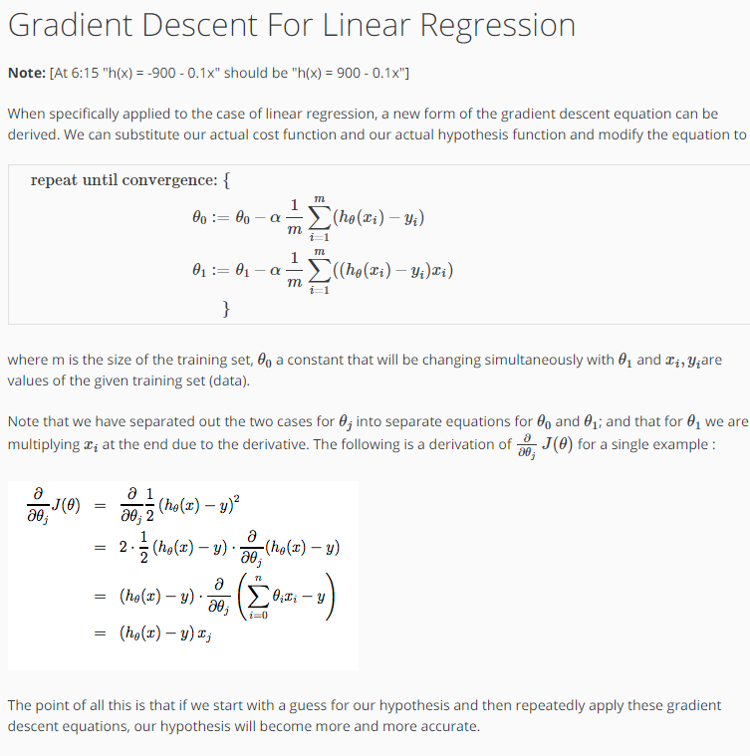Use gradient descent in lots of algos. Going to have assignmnets to implement this later.

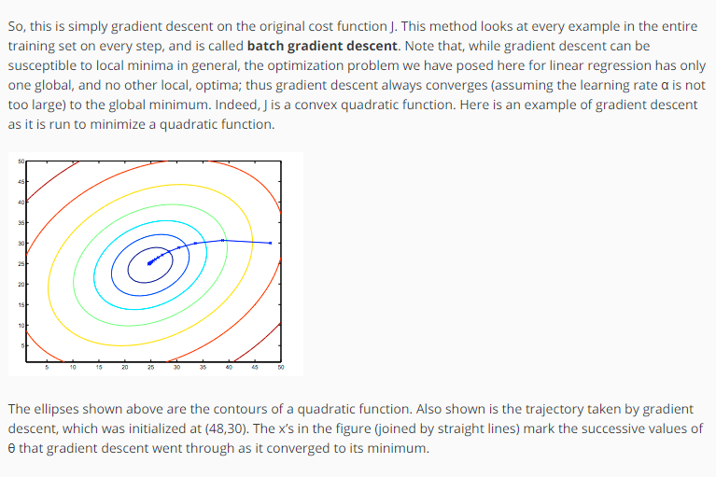

Vid 11 – Matrices and Vectors – This is the linear algebra review section, probably not going to take notes since you should know most of this from Wells’ class. If you don’t, you’ll write it down.

* Matrix – you know what it is.
* $R^{4x2}$ means the set of all real 4x2 real matrices.
* Vector – An n x 1 matrix. N dimensional number: a vector with n entries in it. $R^{4}$ is the set of all real 4 dimensional vectors.
* 1-index vs. 0-indexed vectors exist.
* Unless otherwise specified, for math, 1 index, but with algos, he might use 0 matrices.

Vid 12 – Addition and Scalar multiplication

* Y’know how to add matrices, can’t add matrices of diff dimensions.
* Y’know scalar mult/division. Divide is just multiply by 1/n.

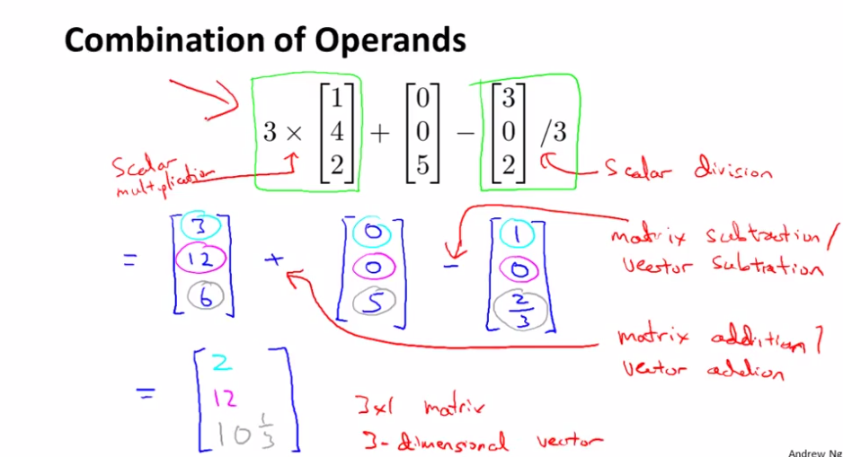

Vid 13 – Matrix multiplication

* M x n * n x whatever = m x whatever matrix.
* Okay, this is new – matrix vector multiplication to simplify expression of a model’s prediction.
* Writing code in style to the left allows it to be much more computationaly efficient than doing it on the way on the left.

Vid 14 – Matrix-matrix multiplication

* Lots of linear algebra libraries to do this multiplication for you.
* Can apply all data sets to all hypothesis to get a bunch at the same time.

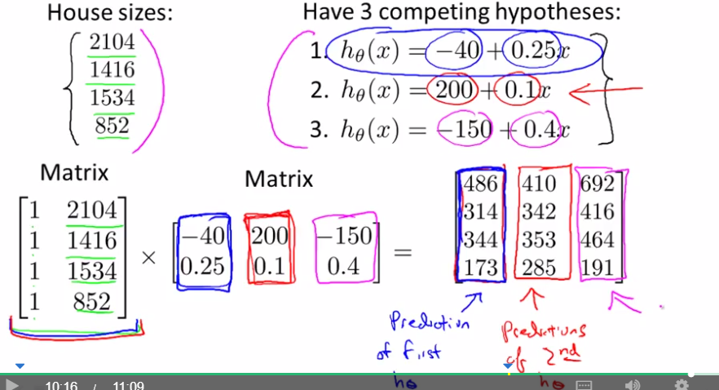



Vid 15 – Matrix Multiplication Properties

* Matrix-matrix multiplication is not communitive.
* Matrix-matrix mult is associative. 2 x 5 x 4 = 2 x (5 x 4) = (2 x 5) x 4
* The identify matrix. Diagonal of 1 with zeroes as all the other entries.

Vid 16 – Inverse and Transpose

* If a matrix is an m x m matrix, and if it has an inverse, then A x A^-1 = A^-1 x A = I.
* Oh he’s going to get the inverse using Octave.
* He’ll tell what It means for an algo to have an inverse. Not going to define it for the scope of this class.
* Matrices that don’t have an inverse are called singular or degenerate matrices.
* Then talks about $A^{T}$
* That’s all the linear algebra we need for this course.

Vid 17 – Linear Regression with Multiple Variables – Multiple Features

* More powerful that one variable.
* In original version, had one feature (size of house), wanted to predict cost.
* Now, not only do we have size, but we have num bedrooms, num floors, age o’ home.
  + X_1, x_2, x_3, x_4, and y for inputs/output
* n = num features, x^i = input features of i^th training example, x^i_j is the value of feature j in the i^th training example.
  + x^i returns an n-dimensional feature vector.
* Then a question to see if we understand notation. Lol didn’t read q, got it wrong, obv know what it is. But damn it, would’ve wrong’d on an exam.
* Previously, hypothesis was h_theta(x) = theta_0 + theta_1(x), but that’s simple.
* NOW IT’s h_theta(x) = theta_0 + theta_1(x_1) + theta_2(x_2) + theta_3(x_3) + theta_4(x_4) + … + theta_n(x_n).
* X_0 = 1 lol implied.
* X = an n x 1 column vector, while theta = an n x 1 column vector, both in $R^{n+1}$, like x/theta = [x_0; x_1; x_2; x_3; …; x_n] (using octave notation)
* h_theta(x) = theta^T(x) so theta transpose times x. This is called multivariate linear regression.

# Multiple Features

**Note:** [7:25 - *θT* is a 1 by (n+1) matrix and not an (n+1) by 1 matrix]

Linear regression with multiple variables is also known as "multivariate linear regression".

We now introduce notation for equations where we can have any number of input variables.

|  |
| --- |
| *x*(*i*)*jx*(*i*)*mn*=value of feature *j* in the *ith* training example=the input (features) of the *ith* training example=the number of training examples=the number of features |

The multivariable form of the hypothesis function accommodating these multiple features is as follows:

*hθ*(*x*)=*θ*0+*θ*1*x*1+*θ*2*x*2+*θ*3*x*3+⋯+*θnxn*

In order to develop intuition about this function, we can think about *θ*0 as the basic price of a house, *θ*1 as the price per square meter, *θ*2 as the price per floor, etc. *x*1 will be the number of square meters in the house, *x*2 the number of floors, etc.

Using the definition of matrix multiplication, our multivariable hypothesis function can be concisely represented as:

|  |
| --- |
| *hθ*(*x*)=[*θ*0*θ*1...*θn*]⎡⎣⎢⎢⎢*x*0*x*1⋮*xn*⎤⎦⎥⎥⎥=*θTx* |

This is a vectorization of our hypothesis function for one training example; see the lessons on vectorization to learn more.

Remark: Note that for convenience reasons in this course we assume *x*(*i*)0=1 for (*i*∈1,…,*m*). This allows us to do matrix operations with theta and x. Hence making the two vectors '*θ*' and *x*(*i*) match each other element-wise (that is, have the same number of elements: n+1).]

Vid 18 – Gradient Descent for Multiple Variables

* theta is an n+1 dimensional vector.

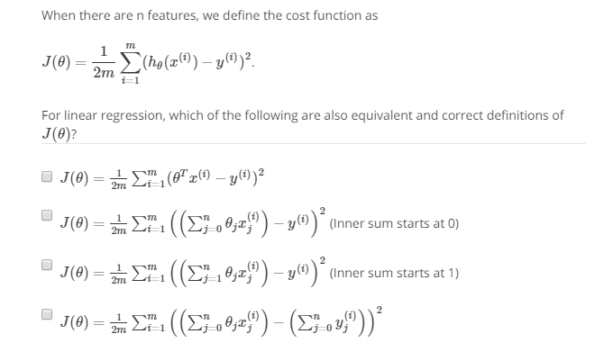

* ima say…the first one? Dammit it was checkboxes, it was the first and second one.

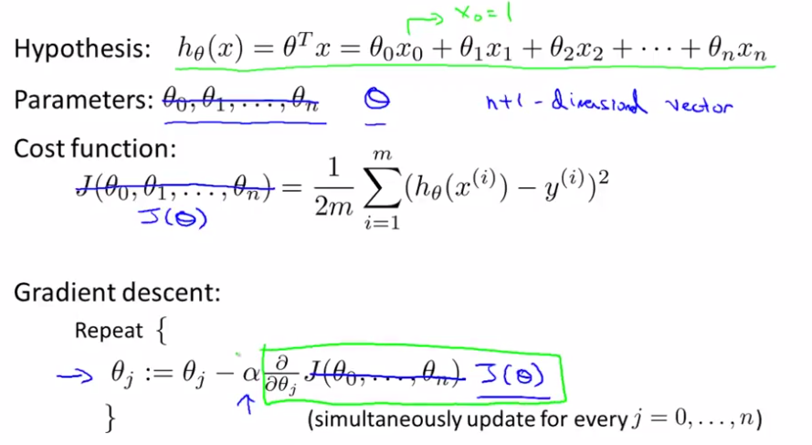

* 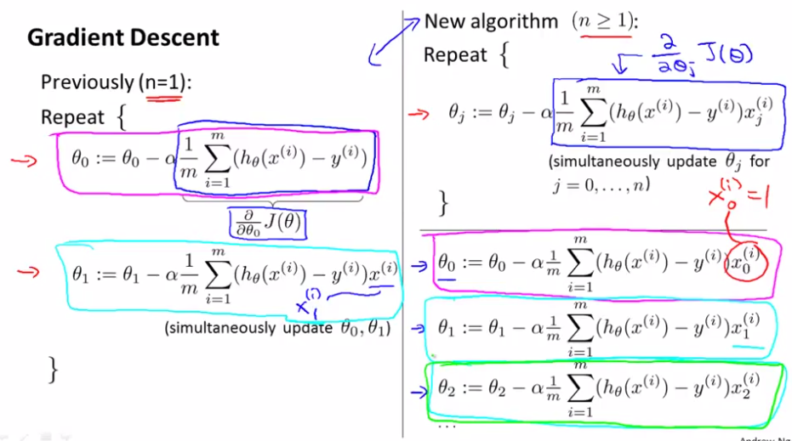Previously had the other stuff for n = 1, the partial differentials.

Gradient Descent For Multiple Variables

**Gradient Descent for Multiple Variables**

The gradient descent equation itself is generally the same form; we just have to repeat it for our 'n' features:

|  |
| --- |
| }repeat until convergence:{*θ*0:=*θ*0−*α*1*m*∑*i*=1/*m*(*hθ*(*x*(*i*))−*y*(*i*))⋅*x*(*i*)0*θ*1:=*θ*1−*α*1/*m*∑*i*=1*m*(*hθ*(*x*(*i*))−*y*(*i*))⋅*x*(*i*)1*θ*2:=*θ*2−*α*1/*m*∑*i*=1*m*(*hθ*(*x*(*i*))−*y*(*i*))⋅*x*(*i*)2⋯ |

In other words:

|  |
| --- |
| }repeat until convergence:{*θj*:=*θj*−*α*1/*m*∑*i*=1*m*(*hθ*(*x*(*i*))−*y*(*i*))⋅*x*(*i*)*j*for j := 0...n |

The following image compares gradient descent with one variable to gradient descent with multiple variables:

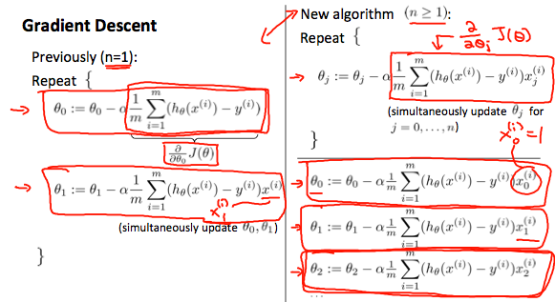

Vid 19 – Gradient Descent in Practice I – Feature Scaling

* If you have a problem w/ multiple features, if the features are on a similar scale, as in they’re around the same values, they are going to converge quicker.
* E.g. x_1 = size(0-2000 feet^2) and x_2 = # bedrooms (1-5)
  + Form really elliptical contours on a plot of theta_1 and theta_2. The gradient descent steps would go up and down and would take a while to reach the center.
* If it was an incredibly tall, skinny contours, gradient descent would have a harder time zig-zagging its way to the global minimum.
* In these, a useful thing to do is scale the features. X_1 = size(feet^2)/2000 and x_2 = num bedrooms /5, so num/max num.
* That way, contours are circular, and can find a single way to get there.
* Would have 0 <= x_1/x_2 <= 1.
* Feature scaling – get every feature into approximately a -1 <= x_i <= 1 range.
  + X_0 = 1
* If you end up having a different feature that’s 0 <= x_1 <= 3 or -2 <= x_2 <= 0.5, that’s fine, as long as it’s close to -1 and 1.
  + Nothing too big or small or else it’s poorly scaled.
  + Andrew Ng says -3 to +3 or -1/3 to 1/3 then that’s ok.
* Mean Normalization – replace x_i with x_i – $μ_{i}$ to make features have approximately zero mean (do not apply to x_0 = 1).
  + E.g. x_1 = size – 1000/ 2000 if average size of a house is 100, x_2 = #bedrooms – 2 / 5 if average house has 2 zeroes.
  + -0.5 <= x_1/x_2 <= 0.5 or slightly larger.
* X_1 🡨 x_1 – mu_1 / s_1
  + Mu_1 is the average value of x_1 in the training set
  + S_1 is the range or standard deviation is ok too, but max – min is good too.
* X_2 🡨 x_2 – mu_1 / s_2 should that be mu_2? It should be, found a mistake in the videos that isn’t addressed in the reading afterwards.

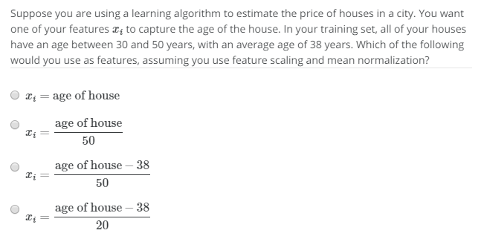

* Ima say… the last one. Ayyyyyyy

# Gradient Descent in Practice I - Feature Scaling

**Note:** [6:20 - The average size of a house is 1000 but 100 is accidentally written instead]

We can speed up gradient descent by having each of our input values in roughly the same range. This is because θ will descend quickly on small ranges and slowly on large ranges, and so will oscillate inefficiently down to the optimum when the variables are very uneven.

The way to prevent this is to modify the ranges of our input variables so that they are all roughly the same. Ideally:

−1 ≤ *x*(*i*) ≤ 1

or

−0.5 ≤ *x*(*i*) ≤ 0.5

These aren't exact requirements; we are only trying to speed things up. The goal is to get all input variables into roughly one of these ranges, give or take a few.

Two techniques to help with this are **feature scaling** and **mean normalization**. Feature scaling involves dividing the input values by the range (i.e. the maximum value minus the minimum value) of the input variable, resulting in a new range of just 1. Mean normalization involves subtracting the average value for an input variable from the values for that input variable resulting in a new average value for the input variable of just zero. To implement both of these techniques, adjust your input values as shown in this formula:

*xi*:=*xi*−*μi/si*

Where *μi* is the **average** of all the values for feature (i) and *si* is the range of values (max - min), or *si* is the standard deviation.

Note that dividing by the range, or dividing by the standard deviation, give different results. The quizzes in this course use range - the programming exercises use standard deviation.

For example, if *xi* represents housing prices with a range of 100 to 2000 and a mean value of 1000, then, *xi*:=*price*−10001900.

Vid 20 – Gradient Descent in Practice II - Learning Rate

* More practical ideas to get gradient descent to work.
* Debugging – how to make sure gradient descent is working correctly.
* How to choose alpha.
* Current Gradeint descent equation: $θ_{j}≔θ_{j}-α\frac{∂}{∂θ_{j}}J\left(θ\right)$
* Something he does to make sure it’s working correctly. Plot J(theta) as gradient descent goes. Should be going down approaching zero.

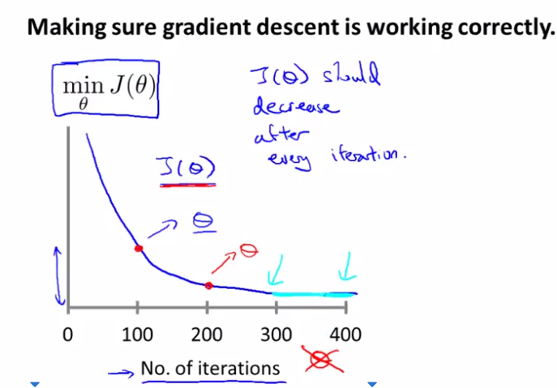

* Num of iterations can vary depending on stuff, there are algorithms that exist which tell you if it’s converging or nah.
* Example automatic convergence test: declare convergence if J(theta) decreases by less than 10^-3 in one iteration, 10^-3 is some small value $ϵ$. The epsilon picking can be difficult, so look at plots is more easier to see.
* If you see a plot where J(theta) is increasing, then it’s not converging and not working, usually means to use a smaller alpha. Also make sure you don’t got bugs.
* May also see J(theta) go down, then up, then down, then up, fix for this is also smaller alpha.
* For sufficiently small alpha, then J(theta) should decrease on every iteration.
* 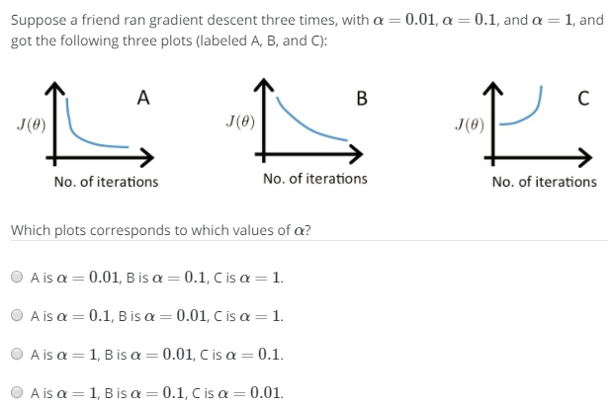If it’s too small, gradient descent can be slow to converge.
* Ima say…B. ayyyyyy.
* Summary – if alpha is too small, slow convergence. If alpha is too big, J(theta) may not decrease on every iteration; may not converge.
* To choose alpha, try …, 0.001, 0.003, 0.01, 0.03, 0.1, 0.3, 1, … and plot the value of J(theta) versus # iterations. Find one value that’s too large, and one value that’s too small, and pick one that’s slightly smaller than first too largest value.

# Gradient Descent in Practice II - Learning Rate

**Note:** [5:20 - the x -axis label in the right graph should be *θ* rather than No. of iterations ]

**Debugging gradient descent.** Make a plot with number of iterations on the x-axis. Now plot the cost function, J(θ) over the number of iterations of gradient descent. If J(θ) ever increases, then you probably need to decrease α.

**Automatic convergence test.** Declare convergence if J(θ) decreases by less than E in one iteration, where E is some small value such as 10−3. However in practice it's difficult to choose this threshold value.

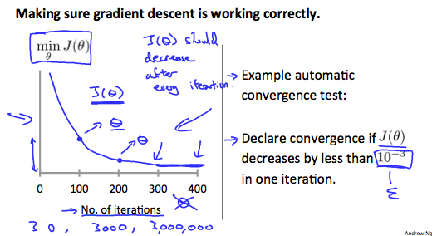

It has been proven that if learning rate α is sufficiently small, then J(θ) will decrease on every iteration.

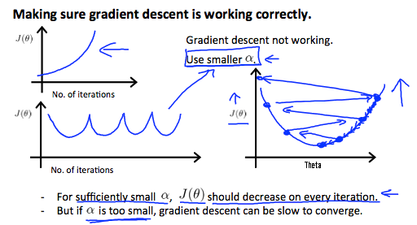

To summarize:

If *α* is too small: slow convergence.

If *α* is too large: may not decrease on every iteration and thus may not converge.

Vid 21 – Features and polynomial regression

* Choice of features, how you can get different learning algos by picking different features.
* Also going to talk about polynomial regression, which allows you to use machinery of linear regression to polynomials
* Suppose you have h(theta) = theta_0 + theta_1 x frontage + theta_2 x depth of house.
  + Want to predict housing prices
* Don’t need to use just x_1 and x_2, can create new features by myself.
  + For this example, can use the area instead. x = frontage * depth.
  + h(theta) = theta_0 + theta_1(x) 🡨 land area is x.
* use multivariate linear regression for polynomial regression.

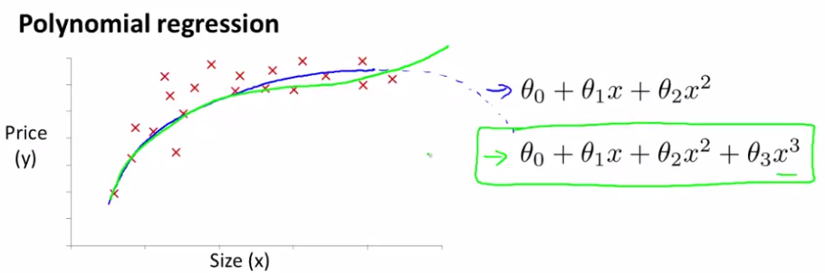

* the blue one doesn’t make sense since it’ll go down, and housing prices don’t go down with size going up. The green one is better, how do we decide to use it/get it?
* Using machinery of multivariate linear regression, can do it with simple modification.

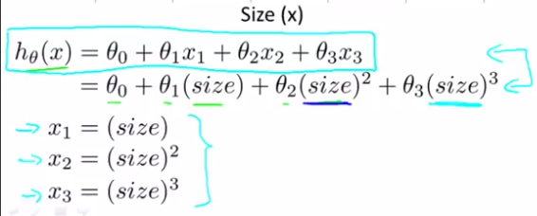

* And that just works apparently. But feature scaling is super important for this then – if size = 1 – 1000, then max of size^3 = 1 – 10^9.
* Choice of features: quadratic function may not be good for this example but rather than going to a cubic model, there can be other possible choices.
* 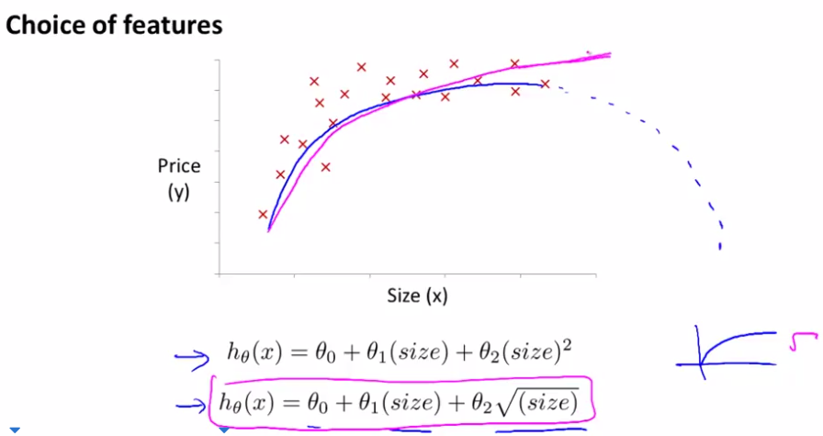just having insight into what a square root func looks like helps, basically says there may be a theta_0, theta_1, theta_2 value that generates something like the pink below.
  + WAIT, so how do we pick thetas?
* Question
* 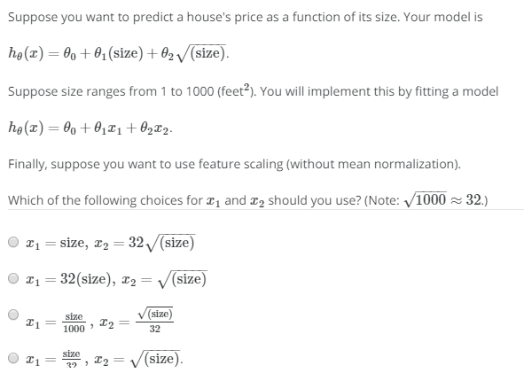ima say…the third option because of scaling. Yep, right.
* Talked about polynomial regression, can use land area of the house.
* 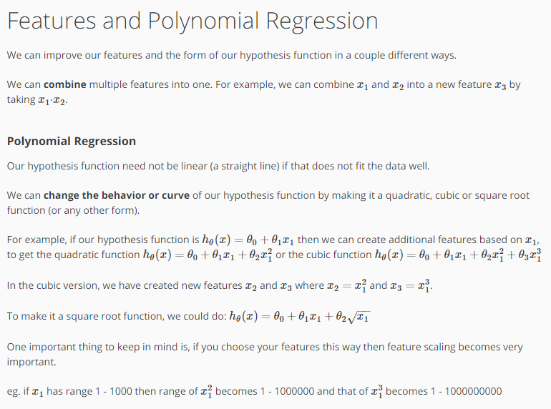Later we choose which features should be used to design functions from an algorithm that automatically picks it.

Vid 22 – Normal Equation

* This equation will help us solve for theta. Right now, we’re using gradient descent.
* It’s an iterative algorithm that takes many steps.
* Normal equation solves for theta analytically. One step and get to optima.
* Simplified cost function, just a function of a real number theta.
* J(theta) = a * theta^2 + b * theta + c
* Want to minimize this function. How? Well, can take derivatives.
* Derivative of this is set equal to 0 and solve for theta that minimizes J(theta).
* Derivative is 2a * theta + b btw. But anyway, in the problem we’re interested in, theta isn’t just a real number, but it’s a R^n+1 parameter vector, and J(theta_0…theta_m) = 1/2m * (Summation(i = 1…m) of h_theta(x^i) – y^i)^2.
* And take the partial derivative of J(theta) with respect to theta set equal to 0 for every J, and need to solve for theta_0 … theta_n
  + The values of theta will be the minimization of cost function J.
* The derivation is a bit somewhat involved. He won’t go through the derivation but will tell what needs to be done in order to solve for values of theta, or alt. values that will minimize the cost function.
* Now we’re going to apply the normal equations to fit linear equations on a dataset.
* Let’s say we have m = 4.
* Adding a column to the features, then making a matrix.

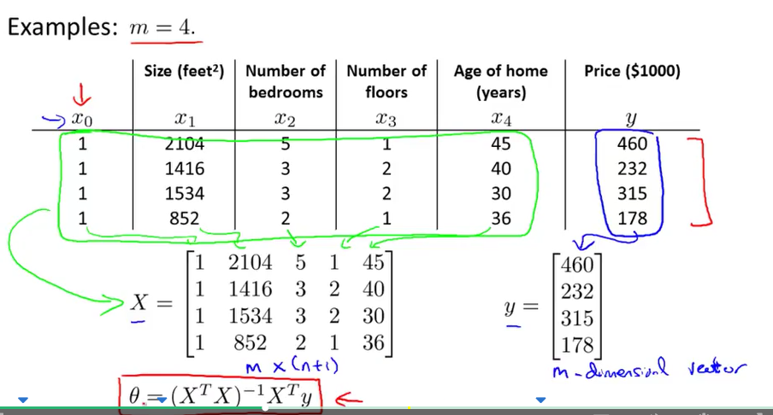

* Then use that equation in red to get theta.
* m examples, n features. Want to construct the design matrix X.
* Right now have x = [x^i_0; x^i_1; x^i_2;…x^i_n]
* X = [ --(x^1)^T--; --(x^2)^T--;…; --(x^m)^T--;] X is an m x (n+1).
* E.g. if x^I = [1; x^i_1] So X = [1 x^1_1; 1 x^2_1; …; 1 x ^m_1] so it’s an m x 2 matrix.
* The vector y (with an arrow on top maybe, doesn’t have to be) is taken by getting the correct values and stacking to get an m dimensional matrix. y = [y^1; y^2; …; y^m].
* Get theta by doing (X^T * X)^-1 * X^T * y.

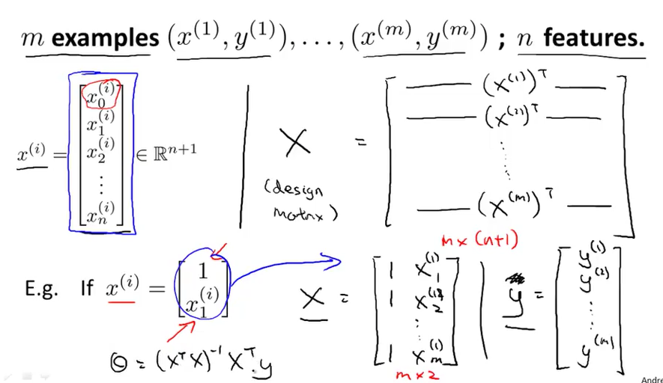

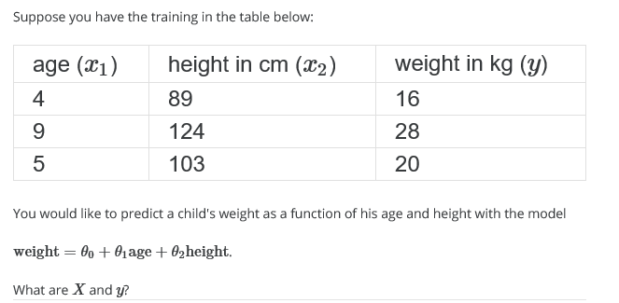

* Ima guess…

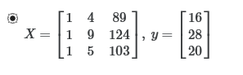

* I was correct!
* $θ={\left(X^{T}X\right)}^{-1}X^{T}y$ is the equation.
* $\left(X^{T}X\right)$ ^-1 is inverse of matrix inside.
* $Octave:pinv\left(X^{'}*X\right)*X^{'}*y$ is the equation up there. Pinv gets the inverse, X’ is the transpose.
$Not going to prove it, but it yields the optimal value of θ.$

$Feature scaling isn^{'}t necessary if using the normal equation method.$

$Howver, if you were using gradient descent, you^{'}dhave to use feature scaling.$

* For m training examples, and n features:
  + Gradient Descent
    - Need to choose α – run it different times with different alphas.
    - needs many iterations – more to the story.
    - Works well when n is large, will do something well.
  + Normal equation
    - No need to choose α
    - Don’t need to iterate. – don’t need to plot and check stuff.
    - Need to compute ${\left(X^{T}X\right)}^{-1} which is an m x \left(n+1\right) matrix-$ cost of inverting it is O(n^3). Wow that’s slow.
    - Slow if n is very large.
  + if n = 100, 1000 not bad for normal equation.
  + If n = 10,000 then inverting that gets pretty slow, then mayyyyy do gradient descent.
  + If n > 10,000 then do gradient descent.
* If n is waaaaay big, use gradient descent. If not, use normal equation.
* Some later sophisticated learning algorithms don’t use normal equation.

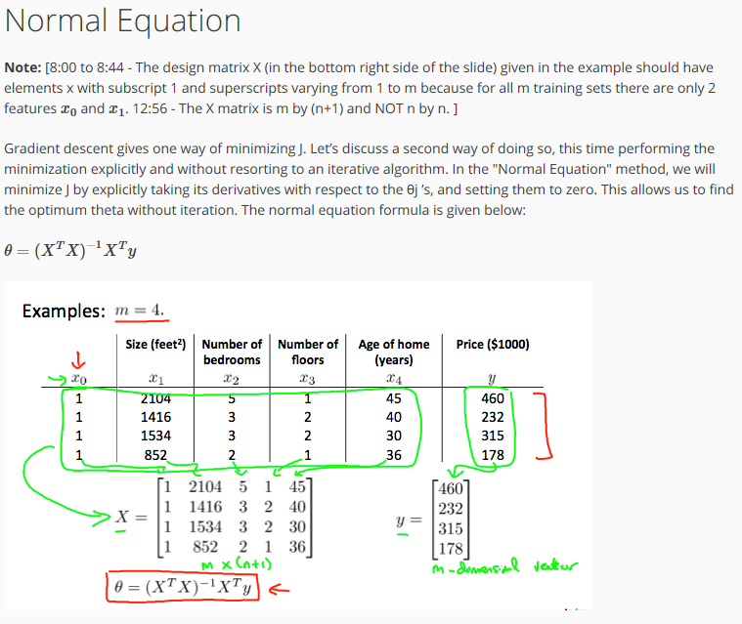

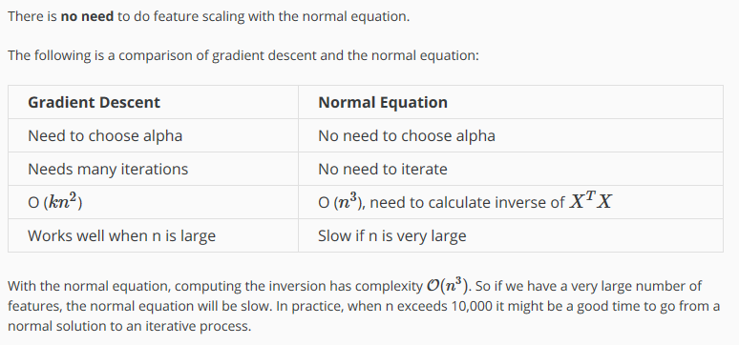

* Gradient descent is O(kn^2)

Vid 23 – Normal Equation and Non-Inevitability

* Advanced concept, asked about it though. This material is optional.
* What if X^T * X is non-invertible? Doesn’t have an inverse? (Singular/degenerate)
  + Rare issue
* Octave: pinv(X’*X)*X’y.
* Computing it in octave will do the right thing.
  + 2 functions for computing invertexes: pinv is the pseudoinverse, inv is the true inverse.
  + Using the pseudoinverse will still get you the theta you want, so we use pinv
* Difference between pseudoinverse and inverse is an advanced num comp concept.
* If if X^T * X is not invertible, it’s b/c it:
  + Has redundant features (linearly dependent)
    - x_1 = size in feet^2
    - x_2 = size in m^2
    - 1m = 3.28 ft.
    - If your two features are related, it’ll be non-invertible.
  + Too many features (e.g. m < n)
    - Delete some features, or use regularization.
    - m = 10, n = 100, with 101 features – pigeonhole principle says there’ll be one extra feature, not enough data.
    - Will see later in course why it’s like this.
  + We’ll talk about regularization later.
* If you find it’s singular, look for redundant features, then just delete one of the similar features.
* If there are too many, delete some features, or use regularization.

# Normal Equation Noninvertibility

When implementing the normal equation in octave we want to use the 'pinv' function rather than 'inv.' The 'pinv' function will give you a value of *θ* even if *X^TX* is not invertible.

If *X^TX* is **noninvertible,** the common causes might be having :

* Redundant features, where two features are very closely related (i.e. they are linearly dependent)
* Too many features (e.g. m ≤ n). In this case, delete some features or use "regularization" (to be explained in a later lesson).

Solutions to the above problems include deleting a feature that is linearly dependent with another or deleting one or more features when there are too many features.

Vid 24 – Octave Tutorial

* How to tell if we’re correct
* They provide files and ask to edit some of them.
* Do the warm up in Octave.
* cd into directory, and then type warmUpExercise()
* should give the output. Then do submit() and hit part 1. Put in login and password, and it’ll give verification. Can use regular website password.

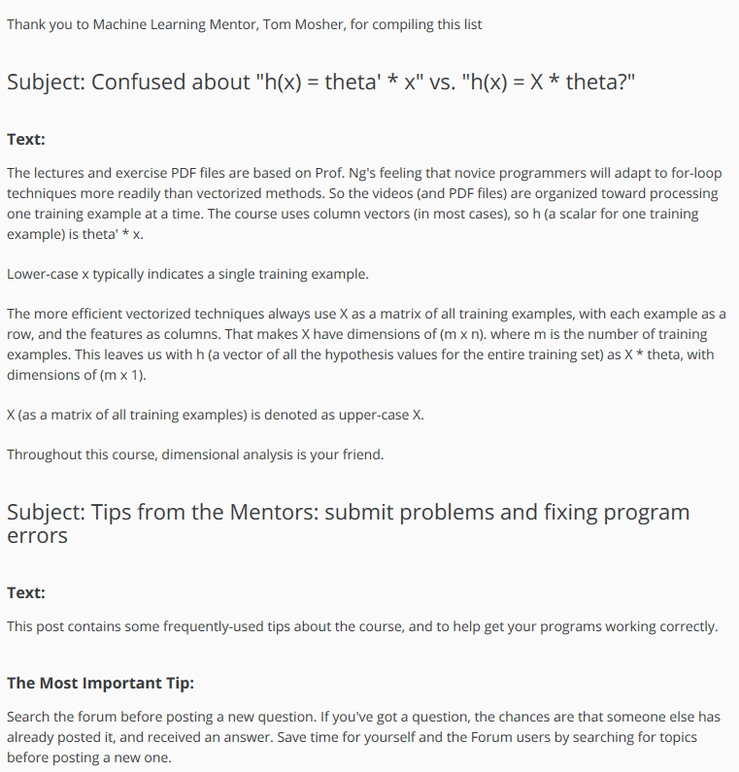

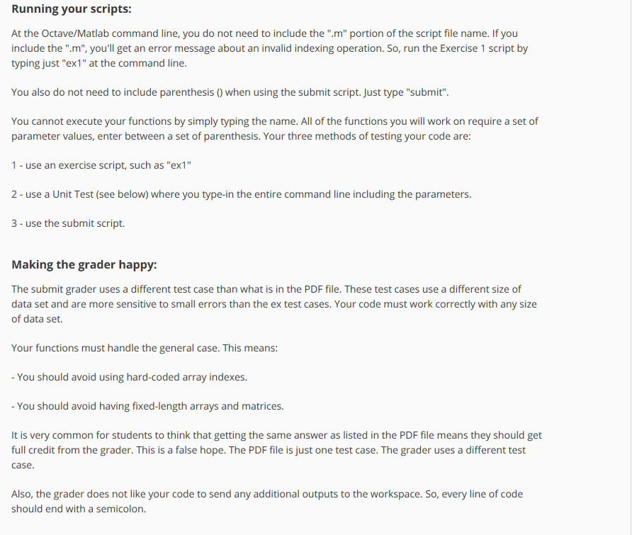

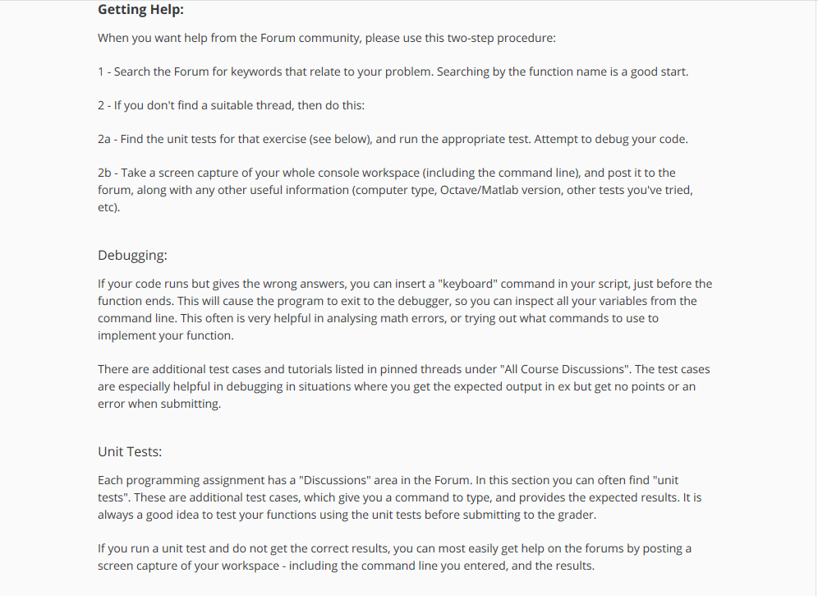

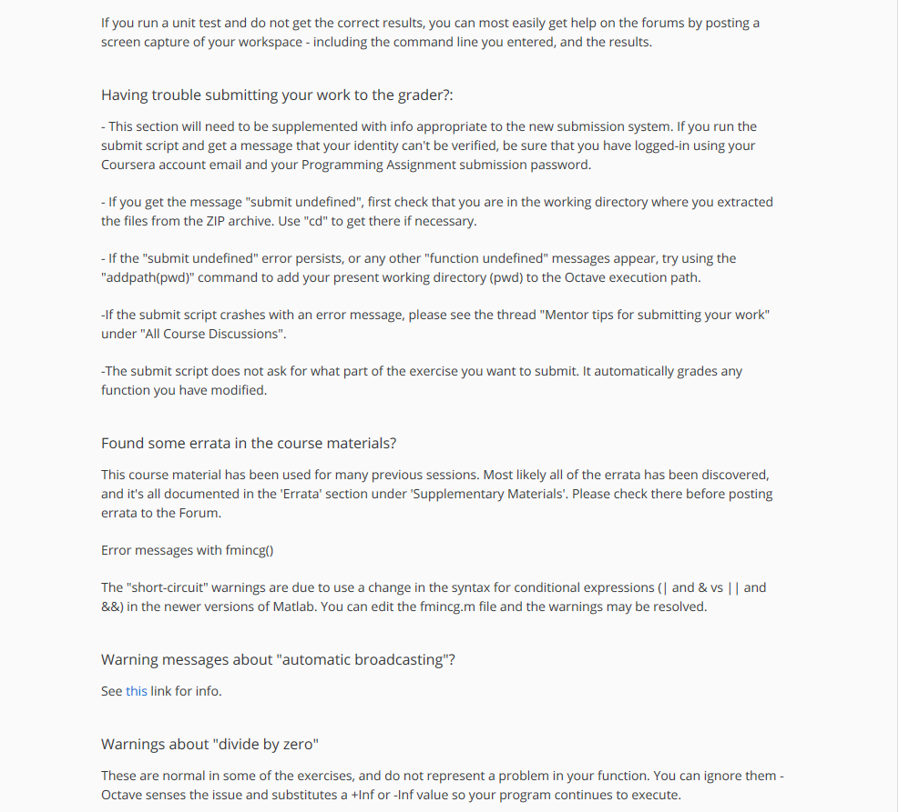

Octave Tutorial Videos by Andrew Ng – Going to watch but might not take notes, since already watched a video series on it. It’s an easy programming language.

Vid 25 – Basic Operations

* in the past, he tried to teach ML in languages like C++ and python, but people learn better with high level programs like octave.
* Will prototype in octave and deploy later.
* Developer time is valuable – can get learning algos to work in octave, then put it after we have ideas working.
* People use octave, MATLAP, python, numpy, R for prototyping.
  + Says people develop slower in python/R since it’s clunkier than octave.
* He really recommends Octave.
* He says to watch these, then install octave, then download transcript of course website.
* Oh hey. I’ll just copy/paste the transcripts.
* Comments are % and then text. 1 ==2, 1 ~= 2, 1 && 0, 1 || 0. Xor(1,0).
* PS1(‘>> ‘)
* PS1 like so. Now my Octave prompt has changed to the greater than, greater than sign.Which, you know, looks quite a bit better. Next let's talk about Octave variables. I can take the variable A and assign it to 3. And hit enter. And now A is equal to 3. You want to assign a variable, but you don't want to print out the result. If you put a semicolon, the semicolon suppresses the print output. So to do that, enter, it doesn't print anything. Whereas A equals 3. mix it, print it out, where A equals, 3 semicolon doesn't print anything. I can do string assignment. B equals hi Now if I just enter B it prints out the variable B. So B is the string hi C equals 3 greater than colon 1. So, now C evaluates the true. If you want to print out or display a variable, here's how you go about it. Let me set A equals Pi. And if I want to print A I can just type A like so, and it will print it out. For more complex printing there is also the DISP command which stands for Display. Display A just prints out A like so. You can also display strings so: DISP, sprintf, two decimals, percent 0.2, F, comma, A. Like so. And this will print out the string. Two decimals, colon, 3.14. This is kind of an old style C syntax. For those of you that have programmed C before, this is essentially the syntax you use to print screen. So the Sprintf generates a string that is less than the 2 decimals, 3.1 plus string. This percent 0.2 F means substitute A into here, showing the two digits after the decimal points. And DISP takes the string DISP generates it by the Sprintf command. Sprintf. The Sprintf command. And DISP actually displays the string. And to show you another example, Sprintf six decimals percent 0.6 F comma A. And, this should print Pi with six decimal places. Finally, I was saying, a like so, looks like this. There are useful shortcuts that type type formats long. It causes strings by default. Be displayed to a lot more decimal places. And format short is a command that restores the default of just printing a small number of digits. Okay, that's how you work with variables. Now let's look at vectors and matrices. Let's say I want to assign MAT A to the matrix. Let me show you an example: 1, 2, semicolon, 3, 4, semicolon, 5, 6. This generates a three by two matrix A whose first row is 1, 2. Second row 3, 4. Third row is 5, 6. What the semicolon does is essentially say, go to the next row of the matrix. There are other ways to type this in. Type A 1, 2 semicolon 3, 4, semicolon, 5, 6, like so. And that's another equivalent way of assigning A to be the values of this three by two matrix. Similarly you can assign vectors. So V equals 1, 2, 3. This is actually a row vector. Or this is a 3 by 1 vector. Where that is a fat Y vector, excuse me, not, this is a 1 by 3 matrix, right. Not 3 by 1. If I want to assign this to a column vector, what I would do instead is do v 1;2;3. And this will give me a 3 by 1. There's a 1 by 3 vector. So this will be a column vector. Here's some more useful notation. V equals 1: 0.1: 2. What this does is it sets V to the bunch of elements that start from 1. And increments and steps of 0.1 until you get up to 2. So if I do this, V is going to be this, you know, row vector. This is what one by eleven matrix really. That's 1, 1.1, 1.2, 1.3 and so on until we get up to two. Now, and I can also set V equals one colon six, and that sets V to be these numbers. 1 through 6, okay. Now here are some other ways to generate matrices. Ones 2.3 is a command that generates a matrix that is a two by three matrix that is the matrix of all ones. So if I set that c2 times ones two by three this generates a two by three matrix that is all two's. You can think of this as a shorter way of writing this and c2,2,2's and you can call them 2,2,2, which would also give you the same result. Let's say W equals one's, one by three, so this is going to be a row vector or a row of three one's and similarly you can also say w equals zeroes, one by three, and this generates a matrix. A one by three matrix of all zeros. Just a couple more ways to generate matrices . If I do W equals Rand one by three, this gives me a one by three matrix of all random numbers. If I do Rand three by three. This gives me a three by three matrix of all random numbers drawn from the uniform distribution between zero and one. So every time I do this, I get a different set of random numbers drawn uniformly between zero and one. For those of you that know what a Gaussian random variable is or for those of you that know what a normal random variable is, you can also set W equals Rand N, one by three. And so these are going to be three values drawn from a Gaussian distribution with mean zero and variance or standard deviation equal to one. And you can set more complex things like W equals minus six, plus the square root ten, times, lets say Rand N, one by ten thousand. And I'm going to put a semicolon at the end because I don't really want this printed out. This is going to be a what? Well, it's going to be a vector of, with a hundred thousand, excuse me, ten thousand elements. So, well, actually, you know what? Let's print it out. So this will generate a matrix like this. Right? With 10,000 elements. So that's what W is. And if I now plot a histogram of W with a hist command, I can now. And Octave's print hist command, you know, takes a couple seconds to bring this up, but this is a histogram of my random variable for W. There was minus 6 plus zero ten times this Gaussian random variable. And I can plot a histogram with more buckets, with more bins, with say, 50 bins. And this is my histogram of a Gaussian with mean minus 6. Because I have a minus 6 there plus square root 10 times this. So the variance of this Gaussian random variable is 10 on the standard deviation is square root of 10, which is about what? Three point one. Finally, one special command for generator matrix, which is the I command. So I stands for this is maybe a pun on the word identity. It's server set eye 4. This is the 4 by 4 identity matrix. So I equals eye 4. This gives me a 4 by 4 identity matrix. And I equals eye 5, eye 6. That gives me a 6 by 6 identity matrix, i3 is the 3 by 3 identity matrix. Lastly, to wrap up this video, there's one more useful command. Which is the help command. So you can type help i and this brings up the help function for the identity matrix. Hit Q to quit. And you can also type help rand. Brings up documentation for the rand or the random number generation function. Or even help help, which shows you, you know help on the help function. So, those are the basic operations in Octave. And with this you should be able to generate a few matrices, multiply, add things. And use the basic operations in Octave. In the next video, I'd like to start talking about more sophisticated commands and how to use data around and start to process data in Octave.
* True is 1, false is 0.
* disp(sprint(‘2 decimals: %0.2f’, a))
* format long
* format short – to display vars as short or loing.
* A = [1, 2; and then enter, 3 4; enter, 5 6] for 3x2 vector.
* V= 1:0.1:2 to make a 1x11 matrix of 1 to 2 with .1 inbetween.
* Ones(2,3) = 2x3 mtx which is mtx of all ones. Can do 2*ones(2x3)
* Rand(3,3), randn(1,3) for Gaussian distribution.
* Sqrt(10).
* Hist(w) is a histogram of matrix.
* Hist(w,50).
* Eye(50,50)

Vid 26 – Moving Data around

Transcription: In this second tutorial video on Octave, I'd like to start to tell you how to move data around in Octave. So, if you have data for a machine learning problem, how do you load that data in Octave? How do you put it into matrix? How do you manipulate these matrices? How do you save the results? How do you move data around and operate with data? Here's my Octave window as before, picking up from where we left off in the last video. If I type A, that's the matrix so we generate it, right, with this command equals one, two, three, four, five, six, and this is a three by two matrix. The size command in Octave lets you, tells you what is the size of a matrix. So size A returns three, two. It turns out that this size command itself is actually returning a one by two matrix. So you can actually set SZ equals size of A and SZ is now a one by two matrix where the first element of this is three, and the second element of this is two. So, if you just type size of SZ. Does SZ is a one by two matrix whose two elements contain the dimensions of the matrix A. You can also type size A one to give you back the first dimension of A, size of the first dimension of A. So that's the number of rows and size A two to give you back two, which is the number of columns in the matrix A.

If you have a vector V, so let's say V equals one, two, three, four, and you type length V. What this does is it gives you the size of the longest dimension. So you can also type length A and because A is a three by two matrix, the longer dimension is of size three, so this should print out three. But usually we apply length only to vectors. So you know, length one, two, three, four, five, rather than apply length to matrices because that's a little more confusing. Now, let's look at how the load data and find data on the file system. When we start an Octave we're usually, we're often in a path that is, you know, the location of where the Octave location is. So the PWD command shows the current directory, or the current path that Octave is in. So right now we're in this maybe somewhat off scale directory. The CD command stands for change directory, so I can go to C:/Users/Ang/Desktop, and now I'm in, you know, in my Desktop and if I type ls, ls is, it comes from a Unix or a Linux command. But, ls will list the directories on my desktop and so these are the files that are on my Desktop right now. In fact, on my desktop are two files: Features X and Price Y that's maybe come from a machine learning problem I want to solve. So, here's my desktop. Here's Features X, and Features X is this window, excuse me, is this file with two columns of data. This is actually my housing prices data. So I think, you know, I think I have forty-seven rows in this data set. And so the first house has size two hundred four square feet, has three bedrooms; second house has sixteen hundred square feet, has three bedrooms; and so on. And Price Y is this file that has the prices of the data in my training set. So, Features X and Price Y are just text files with my data. How do I load this data into Octave? Well, I just type the command load Features X dot dat and if I do that, I load the Features X and can load Price Y dot dat. And by the way, there are multiple ways to do this. This command if you put Features X dot dat on that in strings and load it like so. This is a typo there. This is an equivalent command. So you can, this way I'm just putting the file name of the string in the founding in a string and in an Octave use single quotes to represent strings, like so. So that's a string, and we can load the file whose name is given by that string. Now the WHO command now shows me what variables I have in my Octave workspace. So Who shows me whether the variables that Octave has in memory currently. Features X and Price Y are among them, as well as the variables that, you know, we created earlier in this session. So I can type Features X to display features X. And there's my data. And I can type size features X and that's my 47 by two matrix. And some of these size, press Y, that gives me my 47 by one vector. This is a 47 dimensional vector. This is all common vector that has all the prices Y in my training set. Now the who function shows you one of the variables that, in the current workspace. There's also the who S variable that gives you the detailed view. And so this also, with an S at the end this also lists my variables except that it now lists the sizes as well. So A is a three by two matrix and features X as a 47 by 2 matrix. Price Y is a 47 by one matrix. Meaning this is just a vector. And it shows, you know, how many bytes of memory it's taking up. As well as what type of data this is. Double means double position floating point so that just means that these are real values, the floating point numbers. Now if you want to get rid of a variable you can use the clear command. So clear features X and type whose again. You notice that the features X variable has now disappeared. And how do we save data? Let's see. Let's take the variable V and say that it's a price Y 1 colon 10. This sets V to be the first 10 elements of vector Y. So let's type who or whose. Whereas Y was a 47 by 1 vector. V is now 10 by 1. B equals price Y, one column ten that sets it to the just the first ten elements of Y. Let's say I wanna save this to date to disc the command save, hello.mat V. This will save the variable V into a file called hello.mat. So let's do that. And now a file has appeared on my Desktop, you know, called Hello.mat. I happen to have MATLAB installed in this window, which is why, you know, this icon looks like this because Windows is recognized as it's a MATLAB file,but don't worry about it if this file looks like it has a different icon on your machine and let's say I clear all my variables. So, if you type clear without anything then this actually deletes all of the variables in your workspace. So there's now nothing left in the workspace. And if I load hello.mat, I can now load back my variable v, which is the data that I previously saved into the hello.mat file. So, hello.mat, what we did just now to save hello.mat to view, this save the data in a binary format, a somewhat more compressed binary format. So if v is a lot of data, this, you know, will be somewhat more compressing. Will take off less the space. If you want to save your data in a human readable format then you type save hello.text the variable v and then -ascii. So, this will save it as a text or as ascii format of text. And now, once I've done that, I have this file. Hello.text has just appeared on my desktop, and if I open this up, we see that this is a text file with my data saved away. So that's how you load and save data. Now let's talk a bit about how to manipulate data. Let's set a equals to that matrix again so is my three by two matrix. So as indexing. So type A 3, 2. This indexes into the 3, 2 elements of the matrix A. So, this is what, you know, in normally, we will write this as a subscript 3, 2 or A subscript, you know, 3, 2 and so that's the element and third row and second column of A which is the element of six. I can also type A to comma colon to fetch everything in the second row. So, the colon means every element along that row or column. So, a of 2 comma colon is this second row of a. Right. And similarly, if I do a colon comma 2 then this means get everything in the second column of A. So, this gives me 2 4 6. Right this means of A. everything, second column. So, this is my second column A, which is 2 4 6. Now, you can also use somewhat most of the sophisticated index in the operations. So So, we just click each of an example. You do this maybe less often, but let me do this A 1 3 comma colon. This means get all of the elements of A who's first indexes one or three. This means I get everything from the first and third rows of A and from all columns. So, this was the matrix A and so A 1 3 comma colon means get everything from the first row and from the second row and from the third row and the colon means, you know, one both of first and the second columns and so this gives me this 1 2 5 6. Although, you use the source of more subscript index operations maybe somewhat less often. To show you what else we can do. Here's the A matrix and this source A colon, to give me the second column. You can also use this to do assignments. So I can take the second column of A and assign that to 10, 11, 12, and if I do that I'm now, you know, taking the second column of a and I'm assigning this column vector 10, 11, 12 to it. So, now a is this matrix that's 1, 3, 5. And the second column has been replaced by 10, 11, 12. And here's another operation. Let's set A to be equal to A comma 100, 101, 102 like so and what this will do is depend another column vector to the right. So, now, oops. I think I made a little mistake. Should have put semicolons there and now A is equals to this. Okay? I hope that makes sense. So this 100, 101, 102. This is a column vector and what we did was we set A, take A and set it to the original definition. And then we put that column vector to the right and so, we ended up taking the matrix A and--which was these six elements on the left. So we took matrix A and we appended another column vector to the right; which is now why A is a three by three matrix that looks like that. And finally, one neat trick that I sometimes use if you do just a and just a colon like so. This is a somewhat special case syntax. What this means is that put all elements with A into a single column vector and this gives me a 9 by 1 vector. They adjust the other ones are combined together. Just a couple more examples. Let's see. Let's say I set A to be equal to 123456, okay? And let's say I set a B to B equal to 11, 12, 13, 14, 15, 16. I can create a new matrix C as A B. This just means my Matrix A. Here's my Matrix B and I've set C to be equal to AB. What I'm doing is I'm taking these two matrices and just concatenating onto each other. So the left, matrix A on the left. And I have the matrix B on the right. And that's how I formed this matrix C by putting them together. I can also do C equals A semicolon B. The semi colon notation means that I go put the next thing at the bottom. So, I'll do is a equals semicolon B. It also puts the matrices A and B together except that it now puts them on top of each other. so now I have A on top and B at the bottom and C here is now in 6 by 2 matrix. So, just say the semicolon thing usually means, you know, go to the next line. So, C is comprised by a and then go to the bottom of that and then put b in the bottom and by the way, this A B is the same as A, B and so you know, either of these gives you the same result. So, with that, hopefully you now know how to construct matrices and hopefully starts to show you some of the commands that you use to quickly put together matrices and take matrices and, you know, slam them together to form bigger matrices, and with just a few lines of code, Octave is very convenient in terms of how quickly we can assemble complex matrices and move data around. So that's it for moving data around. In the next video we'll start to talk about how to actually do complex computations on this, on our data. So, hopefully that gives you a sense of how, with just a few commands, you can very quickly move data around in Octave. You know, you load and save vectors and matrices, load and save data, put together matrices to create bigger matrices, index into or select specific elements on the matrices. I know I went through a lot of commands, so I think the best thing for you to do is afterward, to look at the transcript of the things I was typing. You know, look at it. Look at the coursework site and download the transcript of the session from there and look through the transcript and type some of those commands into Octave yourself and start to play with these commands and get it to work. And obviously, you know, there's no point at all to try to memorize all these commands. It's just, but what you should do is, hopefully from this video you have gotten a sense of the sorts of things you can do. So that when later on when you are trying to program a learning algorithms yourself, if you are trying to find a specific command that maybe you think Octave can do because you think you might have seen it here, you should refer to the transcript of the session and look through that in order to find the commands you wanna use. So, that's it for moving data around and in the next video what I'd like to do is start to tell you how to actually do complex computations on our data, and how to compute on the data, and actually start to implement learning algorithms.

* Size(A, 1) gives size of rows, size(A,2) gives size of cols
* Load featuresX.dat
* Who gives current vars.
* Whos yields current scope vars and size and bytes and class, and total.
* Clear <varname> gets rid of a variable.
* V = price(1:10) sets V to be first 10 elements of vector y.
* Save <filename> var to save contents of var to filename
* Save hello.txt v –ascii % save as text (ASCII)
* A(2, :) means every element long that row/col so A(:, 2) also valid
* A([1 3], :) get everything from 1st and third columns of A.
* A(:,2) = [10; 11; 12] assignment
* A = [A, [100; 101; 102]] append another column vector to the right.
* A(:) put all things of a into a column vector.
* C = [A, B] or C = [A; B] to combine them, one for horizontal, one for vertical.

Vid 27 – Computing on Data

Now that you know how to load and

save data in Octave, put your data into matrices and so on. In this video, I'd like to show you how

to do computational operations on data. And later on, we'll be using these source

of computational operations to implement our learning algorithms. Let's get started. Here's my Octave window. Let me just quickly initialize some

variables to use for our example. So set A to be a three by two matrix,

and set B to a three by two matrix, and let's set C to a two

by two matrix like so. Now let's say I want to

multiply two of my matrices. So let's say I want to compute A*C, I just

type A*C, so it's a three by two matrix times a two by two matrix,

this gives me this three by two matrix. You can also do element wise operations

and do A.* B and what this will do is it'll take each element of A and multiply

it by the corresponding elements B, so that's A, that's B, that's A .* B. So for example, the first element

gives 1 times 11, which gives 11. The second element gives 2 time

12 Which gives 24, and so on. So this is element-wise

multiplication of two matrices. And in general, the period tends to, is usually used to denote

element-wise operations in Octave. So here's a matrix A, and if I do A .^ 2, this gives me the element

wise squaring of A. So 1 squared is 1,

2 squared is 4, and so on. Let's set v as a vector. Let's set v as one, two,

three as a column vector. You can also do one dot over v to do

the element-wise reciprocal of v, so this gives me one over one, one over

two, and one over three, and this is where I do the matrices, so one dot over

a gives me the element wise inverse of a. And once again, the period here gives us a

clue that this an element-wise operation. We can also do things like log(v),

this is a element-wise logarithm of the v E to the V is base E

exponentiation of these elements, so this is E, this is E squared EQ,

because this was V, and I can also do abs V to take

the element-wise absolute value of V. So here, V was our positive,

abs, minus one, two minus 3, the element-wise absolute value gives

me back these non-negative values. And negative v gives me the minus of v. This is the same as negative one times v,

but usually you just write

negative v instead of -1*v. And what else can you do? Here's another neat trick. So, let's see. Let's say I want to take v an increment

each of its elements by one. Well one way to do it is

by constructing a three by one vector that's all ones and

adding that to v. So if I do that, this increments

v by from 1, 2, 3 to 2, 3, 4. The way I did that was, length(v) is 3, so ones(length(v),1),

this is ones of 3 by 1, so that's ones(3,1) on the right and

what I did was v plus ones v by one, which is adding this vector of our ones

to v, and so this increments v by one, and another simpler way to do

that is to type v plus one. So she has v, and v plus one also means to add one element

wise to each of my elements of v. Now, let's talk about more operations. So here's my matrix A, if you want to

buy A transposed, the way to do that is to write A prime, that's the apostrophe

symbol, it's the left quote, so it's on your keyboard,

you have a left quote and a right quote. So this is actually

the standard quotation mark. Just type A transpose, this gives

me the transpose of my matrix A. And, of course, A transpose, if I transpose that again,

then I should get back my matrix A. Some more useful functions. Let's say lower case a is 1 15 2 0.5,

so it's 1 by 4 matrix. Let's say val equals max of A this

returns the maximum value of A which in this case is 15 and

I can do val, ind max(a) and this returns val and ind which are going to be the maximum value

of A which is 15, as well as the index. So it was the element number two of A that

was 15 so ind is my index into this. Just as a warning, if you do max(A),

where A is a matrix, what this does is this actually

does the column wise maximum. But say a little more

about this in a second. Still using this example that there for

lowercase a. If I do a < 3,

this does the element wise operation. Element wise comparison, so the first

element of A is less than three so this one. Second element of A is not less than three

so this value says zero cuz it's false. The third and fourth elements of

A are less than three, so that's just 1 1. So that's the element-wise comparison of

all four elements of the variable a < 3. And it returns true or false depending on

whether or not there's less than three. Now, if I do find(a < 3), this will

tell me which are the elements of a, the variable a, that are less than 3, and in this case, the first, third and

fourth elements are less than 3. For our next example,

let me set a to be equal to magic(3). The magic function returns,

let's type help magic. The magic function returns these

matrices called magic squares. They have this, you know, mathematical

property that all of their rows and columns and

diagonals sum up to the same thing. So, you know, it's not actually useful for

machine learning as far as I know, but I'm just using this as a convenient way

to generate a three by three matrix. And these magic squares have

the property that each row, each column, and the diagonals all add

up to the same thing, so it's kind of a mathematical construct. I use this magic function only when I'm

doing demos or when I'm teaching octave like those in, I don't actually use it for

any useful machine learning application. But let's see,

if I type RC = find(A > 7) this finds All the elements of A that

are greater than equal to seven, and so r, c stands for row and column. So the 1,1 element is greater than 7,

the 3,2 element is greater than 7, and the 2,3 element is greater than 7. So let's see. The 2,3 element, for example, is A(2,3), is 7 is this element out here, and

that is indeed greater than equal seven. By the way, I actually don't even memorize

myself what these find functions do and what all of these things do myself. And whenever I use the find function,

sometimes I forget myself exactly what it does, and now I would type help

find to look at the document. Okay, just two more things

that I'll quickly show you. One is the sum function, so

here's my a, and then type sum(a). This adds up all the elements of a, and

if I want to multiply them together, I type prod(a) prod sends the product, and this returns the product of

these four elements of A. Floor(a) rounds down these elements of A,

so 0.5 gets rounded down to 0. And ceil, or ceiling(A) gets

rounded up to the nearest integer, so 0.5 gets rounded up to 1. You can also, let's see. Let me type rand(3),

this generates a three by three matrix. If i type max(rand(3),

what this does is it takes the element-wise maximum of

3 random 3 by 3 matrices. So you notice all of these numbers tend

to be a bit on the large side because each of these is actually

the max of a element wise max of two randomly

generated matrices. This is my magic number. This is my magic square, three by three A. Let's say I type max A, and

then this will be a [], 1, what this does is this

texts the column wise maximum. So the max of the first column is 8,

max of second column is 9, the max of the third column is 7. This 1 means to take the max

among the first dimension of 8. In contrast, if I were to type max A,

this funny notation, two, then this takes the per row maximum. So the max of the first row is eight, max

of second row is seven, max of the third row is nine, and so this allows you to

take maxes either per row or per column. And remember the default's

to a column wise element. So if you want to find the maximum

element in the entire matrix A, you can type max(max(A)) like so,

which is 9. Or you can turn A into a vector and

type max(A(:)) like so and this treats this as a vector and

takes the max element of that vector. Finally let's set A to be

a 9 by 9 magic square. So remember the magic square has

this property that every column and every row sums the same thing,

and also the diagonals, so just a nine by nine matrix square. So let me just sum(A, 1). So this does a per column sum, so

we'll take each column of A and add them up and

this is verified that indeed for a nine by nine matrix square, every column

adds up to 369, adds up to the same thing. Now let's do the row wide sum. So the sum(A,2), and this sums up each row of A, and

indeed each row of A also sums up to 369. Now, let's sum the diagonal

elements of A and make sure that also sums

up to the same thing. So what I'm gonna do is construct a nine

by nine identity matrix, that's eye nine. And let me take A and construct, multiply

A element wise, so here's my matrix A. I'm going to do A .^ eye(9). What this will do is take the element wise

product of these two matrices, and so this should Wipe out everything in A,

except for the diagonal entries. And now,

I'm gonna do sum sum of A of that and this gives me the sum of these diagonal

elements, and indeed that is 369. You can sum up the other

diagonals as well. So this top left to bottom left, you can sum up the opposite diagonal

from bottom left to top right. The commands for

this is somewhat more cryptic, you don't really need to know this. I'm just showing you this in

case any of you are curious. But let's see. Flipud stands for flip up down. But if you do that, that turns out to

sum up the elements in the opposite. So the other diagram,

that also sums up to 369. Here, let me show you. Whereas eye(9) is this matrix. Flipup(eye(9)), takes the identity matrix, and flips it vertically, so

you end up with, excuse me, flip UD, end up with ones on

this opposite diagonal as well. Just one last command and then that's it,

and then that'll be it for this video. Let's set A to be the three

by three magic square game. If you want to invert a matrix,

you type pinv(A). This is typically called

the pseudo-inverse, but it does matter. Just think of it as basically the inverse

of A, and that's the inverse of A. And so I can set temp = pinv(A) and

temp times A, this is indeed the identity matrix, where

it's essentially ones on the diagonals, and zeroes on the off-diagonals,

up to a numeric round off. So, that's it for how to do different computational

operations on data and matrices. And after running a learning algorithm,

often one of the most useful things is to be able to look at your results, so

to plot or visualize your result. And in the next video, I'm going to very

quickly show you how again with one or two lines of code using Octave. You can quickly visualize your data or

plot your data and use that to better understand what

you're learning algorithms are doing.

A * C or A .* B, one is regular mtx mtx mult, the other is bitwise just by elements.

Doing –v is -1 * v

[val, ind] = max(a) so val is 15, and ind = 2 is the max value of a with its index.

A < 3 returns a mtx same value as a with 0s or 1s.

Find(a < 3) returns mtx of indeces.

Magic(N) returns a mtx that generates a mtx where the rows, columns, and diagonals add up to the same thing. Not useful for ML, good for Octave.

[r, c] = find(A >= 7) returns row / col of elements of A in 7. He doesn’t remember stuff, just uses man pages.

Max(A, [], 1) finds all max of first columns of A.

Max(A, [], 2) finds max of rows. Default is columns.

Max(max(a)) finds max of everything, or type max(A(:))

Flipup(mtx) flips diagonals of mtx.

Vid 28 – Plotting Data

When developing learning algorithms, very often a few simple plots can give you a better sense of what the algorithm is doing and just sanity check that everything is going okay and the algorithms doing what is supposed to. For example, in an earlier video, I talked about how plotting the cost function J of theta can help you make sure that gradient descent is converging. Often, plots of the data or of all the learning algorithm outputs will also give you ideas for how to improve your learning algorithm. Fortunately, Octave has very simple tools to generate lots of different plots and when I use learning algorithms, I find that plotting the data, plotting the learning algorithm and so on are often an important part of how I get ideas for improving the algorithms and in this video, I'd like to show you some of these Octave tools for plotting and visualizing your data. Here's my Octave window. Let's quickly generate some data for us to plot. So I'm going to set T to be equal to, you know, this array of numbers. Here's T, set of numbers going from 0 up to .98. Let's set y1 equals sine of 2 pie 40 and if I want to plot the sine function, it's very easy. I just type plot T comma Y 1 and hit enter. And up comes this plot where the horizontal axis is the T variable and the vertical axis is y1, which is the sine you saw in the function that we just computed. Let's set y2 to be equal to the cosine of two pi, four T, like so. And if I plot T comma y2, what octave will I do is I'll take my sine plot and it will replace with this cosine function and now, you know, cosine of xi of 1. Now, what if I want to have both the sine and the cosine plots on top of each other? What I'm going to do is I'm going to type plot t,y1. So here's my sine function, and then I'm going to use the function hold on. And what hold does it closes octaves to now figures on top of the old one and let me now plot t y2. I'm going to plot the cosine function in a different color. So, let me put there r in quotation marks there and instead of replacing the current figure, I'll plot the cosine function on top and the r indicates the what is an event color. And here additional commands - x label times, to label the X axis, or the horizontal axis. And Y label values A, to label the vertical axis value, and I can also label my two lines with this command: legend sine cosine and this puts this legend up on the upper right showing what the 2 lines are, and finally title my plot is the title at the top of this figure. Lastly, if you want to save this figure, you type print -dpng myplot .png. So PNG is a graphics file format, and if you do this it will let you save this as a file. If I do that, let me actually change directory to, let's see, like that, and then I will print that out. So this will take a while depending on how your Octave configuration is setup, may take a few seconds, but change directory to my desktop and Octave is now taking a few seconds to save this. If I now go to my desktop, Let's hide these windows. Here's myplot.png which Octave has saved, and you know, there's the figure saved as the PNG file. Octave can save thousand other formats as well. So, you can type help plot, if you want to see the other file formats, rather than PNG, that you can save figures in. And lastly, if you want to get rid of the plot, the close command causes the figure to go away. As I figure if I type close, that figure just disappeared from my desktop. Octave also lets you specify a figure and numbers. You type figure 1 plots t, y1. That starts up first figure, and that plots t, y1. And then if you want a second figure, you specify a different figure number. So figure two, plot t, y2 like so, and now on my desktop, I actually have 2 figures. So, figure 1 and figure 2 thus 1 plotting the sine function, 1 plotting the cosine function. Here's one other neat command that I often use, which is the subplot command. So, we're going to use subplot 1 2 1. What it does it sub-divides the plot into a one-by-two grid with the first 2 parameters are, and it starts to access the first element. That's what the final parameter 1 is, right? So, divide my figure into a one by two grid, and I want to access the first element right now. And so, if I type that in, this product, this figure, is on the left. And if I plot t, y1, it now fills up this first element. And if I I'll do subplot 122. I'm going to start to access the second element and plot t, y2. Well, throw in y2 in the right hand side, or in the second element. And last command, you can also change the axis scales and change axis these to 1.51 minus 1 1 and this sets the x range and y range for the figure on the right, and concretely, it assess the horizontal major values in the figure on the right to make sure 0.5 to 1, and the vertical axis values use the range from minus one to one. And, you know, you don't need to memorize all these commands. If you ever need to change the access or you need to know is that, you know, there's an access command and you can already get the details from the usual octave help command. Finally, just a couple last commands CLF clear is a figure and here's one unique trait. Let's set a to be equal to a 5 by 5 magic squares a. So, a is now this 5 by 5 matrix does a neat trick that I sometimes use to visualize the matrix, which is I can use image sc of a what this will do is plot a five by five matrix, a five by five grid of color. where the different colors correspond to the different values in the A matrix. So concretely, I can also do color bar. Let me use a more sophisticated command, and image sc A color bar color map gray. This is actually running three commands at a time. I'm running image sc then running color bar, then running color map gray. And what this does, is it sets a color map, so a gray color map, and on the right it also puts in this color bar. And so this color bar shows what the different shades of color correspond to. Concretely, the upper left element of the A matrix is 17, and so that corresponds to kind of a mint shade of gray. Whereas in contrast the second element of A--sort of the 1 2 element of A--is 24. Right, so it's A 1 2 is 24. So that corresponds to this square out here, which is nearly a shade of white. And the small value, say A--what is that? A 4 5, you know, is a value 3 over here that corresponds-- you can see on my color bar that it corresponds to a much darker shade in this image. So here's another example, I can plot a larger, you know, here's a magic 15 that gives you a 15 by 15 magic square and this gives me a plot of what my 15 by 15 magic squares values looks like. And finally to wrap up this video, what you've seen me do here is use comma chaining of function calls. Here's how you actually do this. If I type A equals 1, B equals 2, C equals 3, and hit Enter, then this is actually carrying out three commands at the same time. Or really carrying out three commands, one after another, and it prints out all three results. And this is a lot like A equals 1, B equals 2, C equals 3, except that if I use semicolons instead of a comma, it doesn't print out anything. So, this, you know, this thing here we call comma chaining of commands, or comma chaining of function calls. And, it's just another convenient way in Octave to put multiple commands like image sc color bar, colon map to put multi-commands on the same line. So, that's it. You now know how to plot different figures and octave, and in next video the next main piece that I want to tell you about is how to write control statements like if, while, for statements and octave as well as hard to define and use functions

Vid 29 – Functions, Control Flow

In this video, I'd like to tell you how to write control statements for your Octave programs, so things like "for", "while" and "if" statements and also how to define and use functions. Here's my Octave window. Let me first show you how to use a "for" loop. I'm going to start by setting v to be a 10 by 1 vector 0. Now, here's I write a "for" loop for I equals 1 to 10. That's for I equals Y colon 10. And let's see, I'm going to set V of I equals two to the power of I, and finally end. The white space does not matter, so I am putting the spaces just to make it look nicely indented, but you know spacing doesn't matter. But if I do this, then the result is that V gets set to, you know, two to the power one, two to the power two, and so on. So this is syntax for I equals one colon 10 that makes I loop through the values one through 10. And by the way, you can also do this by setting your indices equals one to 10, and so the indices in the array from one to 10. You can also write for I equals indices. And this is actually the same as if I equals one to 10. You can do, you know, display I and this would do the same thing. So, that is a "for" loop, if you are familiar with "break" and "continue", there's "break" and "continue" statements, you can also use those inside loops in octave, but first let me show you how a while loop works. So, here's my vector V. Let's write the while loop. I equals 1, while I is less than or equal to 5, let's set V I equals one hundred and increment I by one, end. So this says what? I starts off equal to one and then I'm going to set V I equals one hundred and increment I by one until I is, you know, greater than five. And as a result of that, whereas previously V was this powers of two vector. I've now taken the first five elements of my vector and overwritten them with this value one hundred. So that's a syntax for a while loop. Let's do another example. Y equals one while true and here I wanted to show you how to use a break statement. Let's say V I equals 999 and I equals i+1 if i equals 6 break and end. And this is also our first use of an if statement, so I hope the logic of this makes sense. Since I equals one and, you know, increment loop. While repeatedly set V I equals 1 and increment i by 1, and then when 1 i gets up to 6, do a break which breaks here although the while do and so, the effective is should be to take the first five elements of this vector V and set them to 999. And yes, indeed, we're taking V and overwritten the first five elements with 999. So, this is the syntax for "if" statements, and for "while" statement, and notice the end. We have two ends here. This ends here ends the if statement and the second end here ends the while statement. Now let me show you the more general syntax for how to use an if-else statement. So, let's see, V 1 is equal to 999, let's type V1 equals to 2 for this example. So, let me type if V 1 equals 1 display the value as one. Here's how you write an else statement, or rather here's an else if: V 1 equals 2. This is, if in case that's true in our example, display the value as 2, else display, the value is not one or two. Okay, so that's a if-else if-else statement it ends. And of course, here we've just set v 1 equals 2, so hopefully, yup, displays that the value is 2. And finally, I don't think I talked about this earlier, but if you ever need to exit Octave, you can type the exit command and you hit enter that will cause Octave to quit or the 'q'--quits command also works. Finally, let's talk about functions and how to define them and how to use them. Here's my desktop, and I have predefined a file or pre-saved on my desktop a file called "squarethisnumber.m". This is how you define functions in Octave. You create a file called, you know, with your function name and then ending in .m, and when Octave finds this file, it knows that this where it should look for the definition of the function "squarethisnumber.m". Let's open up this file. Notice that I'm using the Microsoft program Wordpad to open up this file. I just want to encourage you, if your using Microsoft Windows, to use Wordpad rather than Notepad to open up these files, if you have a different text editor that's fine too, but notepad sometimes messes up the spacing. If you only have Notepad, that should work too, that could work too, but if you have Wordpad as well, I would rather use that or some other text editor, if you have a different text editor for editing your functions. So, here's how you define the function in Octave. Let me just zoom in a little bit. And this file has just three lines in it. The first line says function Y equals square root number of X, this tells Octave that I'm gonna return the value Y, I'm gonna return one value and that the value is going to be saved in the variable Y and moreover, it tells Octave that this function has one argument, which is the argument X, and the way the function body is defined, if Y equals X squared. So, let's try to call this function "square", this number 5, and this actually isn't going to work, and Octave says square this number it's undefined. That's because Octave doesn't know where to find this file. So as usual, let's use PWD, or not in my directory, so let's see this c:\users\ang\desktop. That's where my desktop is. Oops, a little typo there. Users ANG desktop and if I now type square root number 5, it returns the answer 25. As kind of an advanced feature, this is only for those of you that know what the term search path means. But so if you want to modify the Octave search path and you could, you just think of this next part as advanced or optional material. Only for those who are either familiar with the concepts of search paths and permit languages, but you can use the term addpath, safety colon, slash users/ANG/desktop to add that directory to the Octave search path so that even if you know, go to some other directory I can still, Octave still knows to look in the users ANG desktop directory for functions so that even though I'm in a different directory now, it still knows where to find the square this number function. Okay? But if you're not familiar with the concept of search path, don't worry about it. Just make sure as you use the CD command to go to the directory of your function before you run it and that actually works just fine. One concept that Octave has that many other programming languages don't is that it can also let you define functions that return multiple values or multiple arguments. So here's an example of that. Define the function called square and cube this number X and what this says is this function returns 2 values, y1 and y2. When I set down, this follows, y1 is squared, y2 is execute. And what this does is this really returns 2 numbers. So, some of you depending on what programming language you use, if you're familiar with, you know, CC++ your offer. Often, we think of the function as return in just one value. But just so the syntax in Octave that should return multiple values. Now back in the Octave window. If I type, you know, a, b equals square and cube this number 5 then a is now equal to 25 and b is equal to the cube of 5 equal to 125. So, this is often convenient if you needed to define a function that returns multiple values. Finally, I'm going to show you just one more sophisticated example of a function. Let's say I have a data set that looks like this, with data points at 1, 1, 2, 2, 3, 3. And what I'd like to do is to define an octave function to compute the cost function J of theta for different values of theta. First let's put the data into octave. So I set my design matrix to be 1,1,1,2,1,3. So, this is my design matrix x with x0, the first column being the said term and the second term being you know, my the x-values of my three training examples. And let me set y to be 1-2-3 as follows, which were the y axis values. So let's say theta is equal to 0 semicolon 1. Here at my desktop, I've predefined does cost function j and if I bring up the definition of that function it looks as follows. So function j equals cost function j equals x y theta, some commons, specifying the inputs and then vary few steps set m to be the number trading examples thus the number of rows in x. Compute the predictions, predictions equals x times theta and so this is a common that's wrapped around, so this is probably the preceding comment line. Computer script errors by, you know, taking the difference between your predictions and the y values and taking the element of y squaring and then finally computing the cost function J. And Octave knows that J is a value I want to return because J appeared here in the function definition. Feel free by the way to pause this video if you want to look at this function definition for longer and kind of make sure that you understand the different steps. But when I run it in Octave, I run j equals cost function j x y theta. It computes. Oops, made a typo there. It should have been capital X. It computes J equals 0 because if my data set was, you know, 123, 123 then setting, theta 0 equals 0, theta 1 equals 1, this gives me exactly the 45-degree line that fits my data set perfectly. Whereas in contrast if I set theta equals say 0, 0, then this hypothesis is predicting zeroes on everything the same, theta 0 equals 0, theta 1 equals 0 and I compute the cost function then it's 2.333 and that's actually equal to 1 squared, which is my squared error on the first example, plus 2 squared, plus 3 squared and then divided by 2m, which is 2 times number of training examples, which is indeed 2.33 and so, that sanity checks that this function here is, you know, computing the correct cost function and these are the couple examples we tried out on our simple training example. And so that sanity tracks that the cost function J, as defined here, that it is indeed, you know, seeming to compute the correct cost function, at least on our simple training set that we had here with X and Y being this simple training example that we solved. So, now you know how to right control statements like for loops, while loops and if statements in octave as well as how to define and use functions. In the next video, I'm going to just very quickly step you through the logistics of working on and submitting problem sets for this class and how to use our submission system. And finally, after that, in the final octave tutorial video, I wanna tell you about vectorization, which is an idea for how to make your octave programs run much fast.

Vid 30 – Vectorization

In this video, I'd like to tell you how to write control statements for your Octave programs, so things like "for", "while" and "if" statements and also how to define and use functions. Here's my Octave window. Let me first show you how to use a "for" loop. I'm going to start by setting v to be a 10 by 1 vector 0. Now, here's I write a "for" loop for I equals 1 to 10. That's for I equals Y colon 10. And let's see, I'm going to set V of I equals two to the power of I, and finally end. The white space does not matter, so I am putting the spaces just to make it look nicely indented, but you know spacing doesn't matter. But if I do this, then the result is that V gets set to, you know, two to the power one, two to the power two, and so on. So this is syntax for I equals one colon 10 that makes I loop through the values one through 10. And by the way, you can also do this by setting your indices equals one to 10, and so the indices in the array from one to 10. You can also write for I equals indices. And this is actually the same as if I equals one to 10. You can do, you know, display I and this would do the same thing. So, that is a "for" loop, if you are familiar with "break" and "continue", there's "break" and "continue" statements, you can also use those inside loops in octave, but first let me show you how a while loop works. So, here's my vector V. Let's write the while loop. I equals 1, while I is less than or equal to 5, let's set V I equals one hundred and increment I by one, end. So this says what? I starts off equal to one and then I'm going to set V I equals one hundred and increment I by one until I is, you know, greater than five. And as a result of that, whereas previously V was this powers of two vector. I've now taken the first five elements of my vector and overwritten them with this value one hundred. So that's a syntax for a while loop. Let's do another example. Y equals one while true and here I wanted to show you how to use a break statement. Let's say V I equals 999 and I equals i+1 if i equals 6 break and end. And this is also our first use of an if statement, so I hope the logic of this makes sense. Since I equals one and, you know, increment loop. While repeatedly set V I equals 1 and increment i by 1, and then when 1 i gets up to 6, do a break which breaks here although the while do and so, the effective is should be to take the first five elements of this vector V and set them to 999. And yes, indeed, we're taking V and overwritten the first five elements with 999. So, this is the syntax for "if" statements, and for "while" statement, and notice the end. We have two ends here. This ends here ends the if statement and the second end here ends the while statement. Now let me show you the more general syntax for how to use an if-else statement. So, let's see, V 1 is equal to 999, let's type V1 equals to 2 for this example. So, let me type if V 1 equals 1 display the value as one. Here's how you write an else statement, or rather here's an else if: V 1 equals 2. This is, if in case that's true in our example, display the value as 2, else display, the value is not one or two. Okay, so that's a if-else if-else statement it ends. And of course, here we've just set v 1 equals 2, so hopefully, yup, displays that the value is 2. And finally, I don't think I talked about this earlier, but if you ever need to exit Octave, you can type the exit command and you hit enter that will cause Octave to quit or the 'q'--quits command also works. Finally, let's talk about functions and how to define them and how to use them. Here's my desktop, and I have predefined a file or pre-saved on my desktop a file called "squarethisnumber.m". This is how you define functions in Octave. You create a file called, you know, with your function name and then ending in .m, and when Octave finds this file, it knows that this where it should look for the definition of the function "squarethisnumber.m". Let's open up this file. Notice that I'm using the Microsoft program Wordpad to open up this file. I just want to encourage you, if your using Microsoft Windows, to use Wordpad rather than Notepad to open up these files, if you have a different text editor that's fine too, but notepad sometimes messes up the spacing. If you only have Notepad, that should work too, that could work too, but if you have Wordpad as well, I would rather use that or some other text editor, if you have a different text editor for editing your functions. So, here's how you define the function in Octave. Let me just zoom in a little bit. And this file has just three lines in it. The first line says function Y equals square root number of X, this tells Octave that I'm gonna return the value Y, I'm gonna return one value and that the value is going to be saved in the variable Y and moreover, it tells Octave that this function has one argument, which is the argument X, and the way the function body is defined, if Y equals X squared. So, let's try to call this function "square", this number 5, and this actually isn't going to work, and Octave says square this number it's undefined. That's because Octave doesn't know where to find this file. So as usual, let's use PWD, or not in my directory, so let's see this c:\users\ang\desktop. That's where my desktop is. Oops, a little typo there. Users ANG desktop and if I now type square root number 5, it returns the answer 25. As kind of an advanced feature, this is only for those of you that know what the term search path means. But so if you want to modify the Octave search path and you could, you just think of this next part as advanced or optional material. Only for those who are either familiar with the concepts of search paths and permit languages, but you can use the term addpath, safety colon, slash users/ANG/desktop to add that directory to the Octave search path so that even if you know, go to some other directory I can still, Octave still knows to look in the users ANG desktop directory for functions so that even though I'm in a different directory now, it still knows where to find the square this number function. Okay? But if you're not familiar with the concept of search path, don't worry about it. Just make sure as you use the CD command to go to the directory of your function before you run it and that actually works just fine. One concept that Octave has that many other programming languages don't is that it can also let you define functions that return multiple values or multiple arguments. So here's an example of that. Define the function called square and cube this number X and what this says is this function returns 2 values, y1 and y2. When I set down, this follows, y1 is squared, y2 is execute. And what this does is this really returns 2 numbers. So, some of you depending on what programming language you use, if you're familiar with, you know, CC++ your offer. Often, we think of the function as return in just one value. But just so the syntax in Octave that should return multiple values. Now back in the Octave window. If I type, you know, a, b equals square and cube this number 5 then a is now equal to 25 and b is equal to the cube of 5 equal to 125. So, this is often convenient if you needed to define a function that returns multiple values. Finally, I'm going to show you just one more sophisticated example of a function. Let's say I have a data set that looks like this, with data points at 1, 1, 2, 2, 3, 3. And what I'd like to do is to define an octave function to compute the cost function J of theta for different values of theta. First let's put the data into octave. So I set my design matrix to be 1,1,1,2,1,3. So, this is my design matrix x with x0, the first column being the said term and the second term being you know, my the x-values of my three training examples. And let me set y to be 1-2-3 as follows, which were the y axis values. So let's say theta is equal to 0 semicolon 1. Here at my desktop, I've predefined does cost function j and if I bring up the definition of that function it looks as follows. So function j equals cost function j equals x y theta, some commons, specifying the inputs and then vary few steps set m to be the number trading examples thus the number of rows in x. Compute the predictions, predictions equals x times theta and so this is a common that's wrapped around, so this is probably the preceding comment line. Computer script errors by, you know, taking the difference between your predictions and the y values and taking the element of y squaring and then finally computing the cost function J. And Octave knows that J is a value I want to return because J appeared here in the function definition. Feel free by the way to pause this video if you want to look at this function definition for longer and kind of make sure that you understand the different steps. But when I run it in Octave, I run j equals cost function j x y theta. It computes. Oops, made a typo there. It should have been capital X. It computes J equals 0 because if my data set was, you know, 123, 123 then setting, theta 0 equals 0, theta 1 equals 1, this gives me exactly the 45-degree line that fits my data set perfectly. Whereas in contrast if I set theta equals say 0, 0, then this hypothesis is predicting zeroes on everything the same, theta 0 equals 0, theta 1 equals 0 and I compute the cost function then it's 2.333 and that's actually equal to 1 squared, which is my squared error on the first example, plus 2 squared, plus 3 squared and then divided by 2m, which is 2 times number of training examples, which is indeed 2.33 and so, that sanity checks that this function here is, you know, computing the correct cost function and these are the couple examples we tried out on our simple training example. And so that sanity tracks that the cost function J, as defined here, that it is indeed, you know, seeming to compute the correct cost function, at least on our simple training set that we had here with X and Y being this simple training example that we solved. So, now you know how to right control statements like for loops, while loops and if statements in octave as well as how to define and use functions. In the next video, I'm going to just very quickly step you through the logistics of working on and submitting problem sets for this class and how to use our submission system. And finally, after that, in the final octave tutorial video, I wanna tell you about vectorization, which is an idea for how to make your octave programs run much fast.